Harvest wild plants and useful species from marginal lands.

**ECOTONE**: In nature the edge between two ecosystems is called an ecotone. These areas usually contain a higher diversity of species than either ‘overlapping’ ecosystems. Gross photosynthetic production is also higher at such ‘interfaces’. By following this ‘pattern’ and increasing the edges within our system we can increase photosynthetic production and therefore yield.

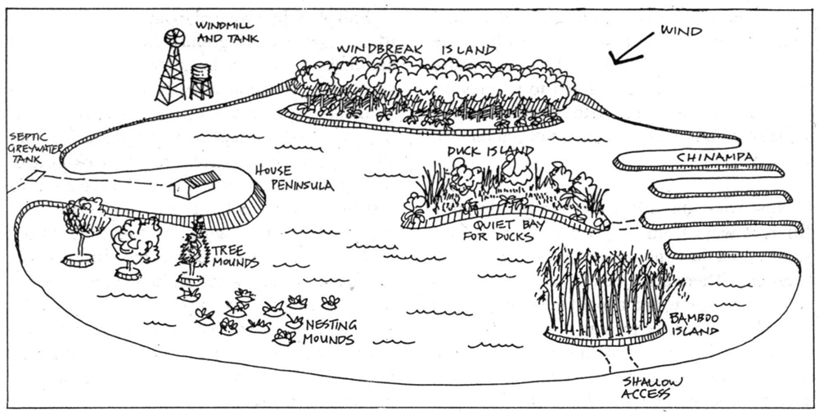

**Identify, create and utilise edges**

**10. Principle of Edge Effects**

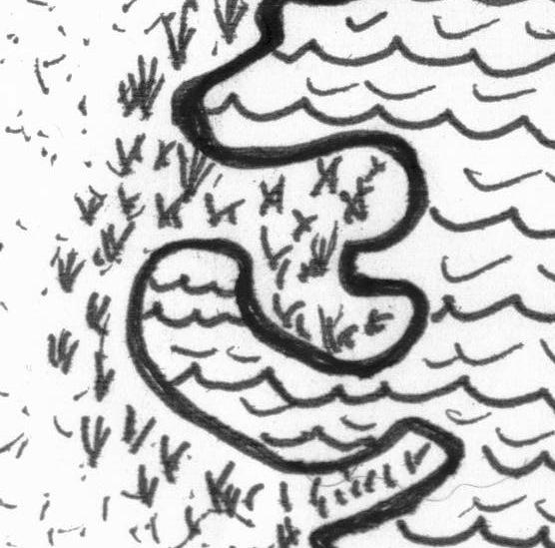

**H11. Use edges and value the marginal.**

*“Don’t think you are on the right track just because it is a well-beaten path”.*

The interface between things is where the most interesting events take place. These are often the most valuable, diverse and productive elements in the system.

Using earthbanks and islands in and around water provide many edges (niches) for plants, animals, and people. Illustration: Mollison & Slay, 1991, *Introduction to Permaculture*, p.27, fig.1.11

|  |  |
| --- | --- |
| cold | hot |
| wet | dry |
| wet season | dry season |
| earth | sky |
| natural | built |
| house | garden |
| road | footpath |
| estuary | ocean |
| forest | grassland |
| highway | property line |

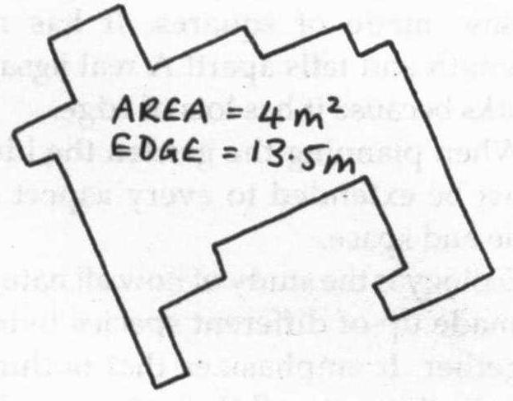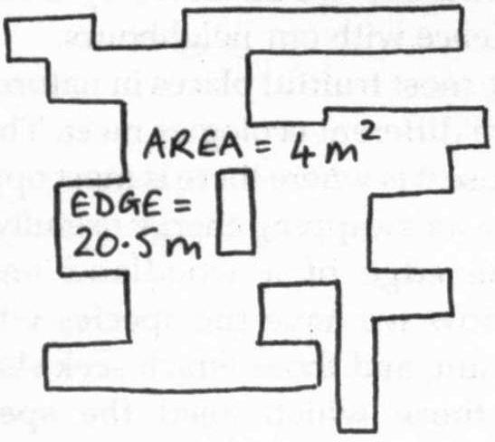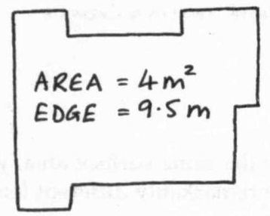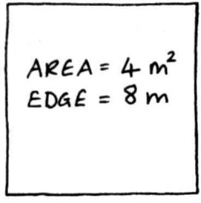

Illustration: Bell, 1994, *The Permaculture Garden*, p. 24.

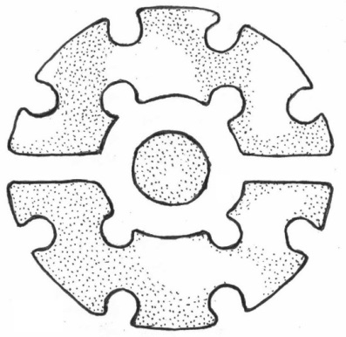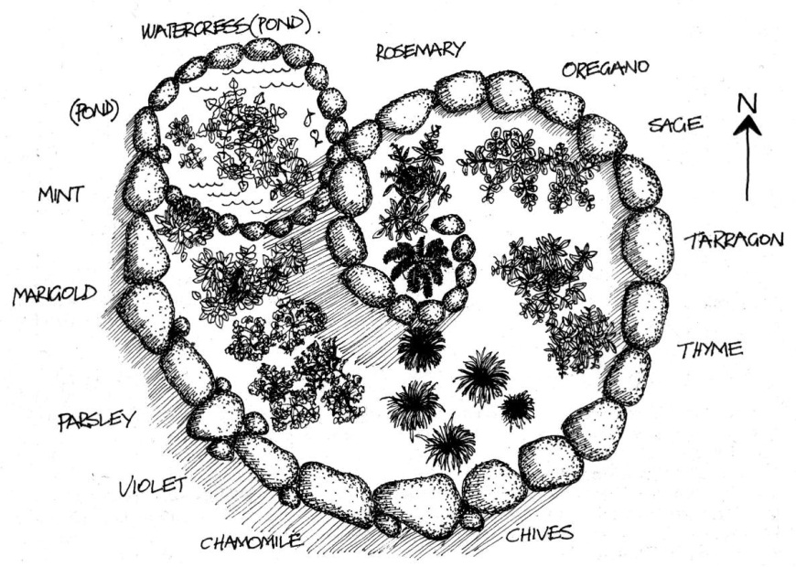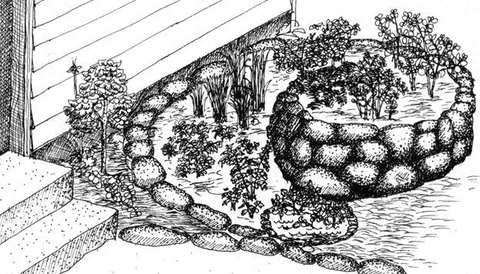

**PRINCIPLES**

**Mind-map 10**

**8.**

Illustration: Mollison, 1979, *Permaculture Two*, p.11, fig.2.1

**HERB SPIRAL**

A spiral is a useful pattern as the amount of edge and growing space increases as the garden bed climbs higher. To construct dump a pile of soil on the ground 2 to 3 metres across, then using rocks construct your spiral. Plant deep rooted herbs on top (or a dwarf lemon tree) and shallow rooted lower; plant sun loving herbs on the sunny side and shade loving ones in the shade.

**MANDALA GARDENS**

Mandala gardens have a greater edge than rectangular beds. They are constructed by ‘joining’ keyhole beds together. Illustration: Mars. 2007, *The Basics of Permaculture Design*, p.132, fig.12.4