**Time stacking** is the process of planting your next crop before your last one is harvested. For example, you may plant a legume crop to enrich the soil while the previous crop is still growing. The bed could then be used for the next crop sooner.

We can also ‘stack in time’ by placing pioneers, young fruit trees, palms (or pole crop), shrubs, windbreak, groundcover, and even annual beds all together and at one time. Eventually annual crops will be shaded out by perennial shrubs and small trees, and in 20 years trees will dominate most of the area. Meanwhile, we have harvested many years of produce and built up the soil through the addition of vegetable wastes and green manuring. Instead of waiting for yields for 6-20 years from tree and nut crops, we get yields from 5-6 months on. (From: Mollison and Slay, 1991, *Introduction to Permaculture,* p. 22)

**Plant stacking** is the placement of useful plant species in every ‘layer’ in such a way that mimics the form of a natural forest. (*Intro to Permaculture*, 1991, p.21, fig.1.9)

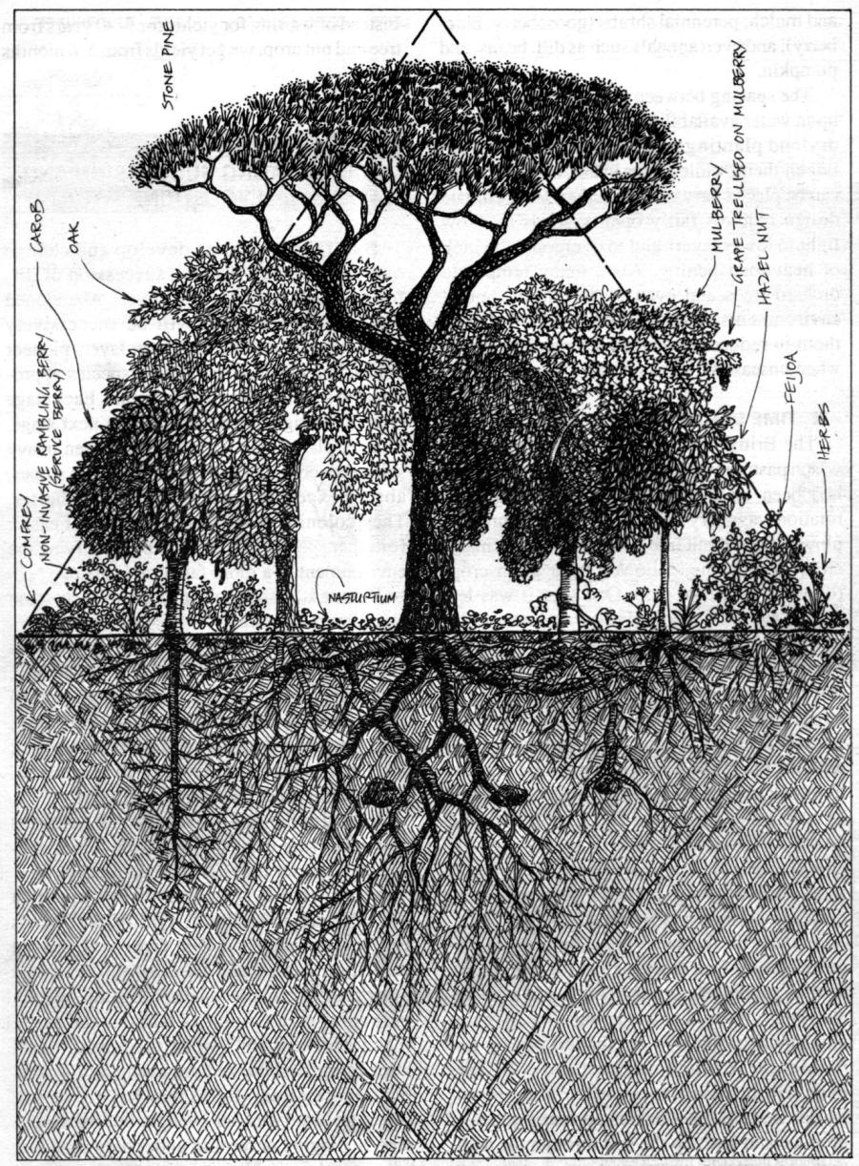

**Develop small-scale intensive systems by stacking and using niches.**

**11. Principle of Intensification**

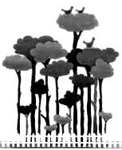

A niche in **time** is often based upon cycles of opportunity. Most annual vegetables grow better if planted at specific times of the year, based on varied day length, precipitation, and temperature (more important in temperate climates). In Townsville just before the wet season is the best time to plant trees.

**H8. Integrate rather than segregate:**

*“Many hands make light work.”*

By putting the right things in the right place, relationships develop between those things and they work together to support each other.

* In every ecosystem different plant species occur at varying heights above ground, and root structures at different depths. Plants grow in response to available light, so that in a forest the mature trees for the uppermost (canopy) layer, with a lower tree stratum of smaller trees using some of the remaining light. The shrub layer, adapted to low light levels, grows beneath, and if there is any more available light, a herb layer forms as the lowest strata (see diagram).
* We can construct our own version of the forest by establishing an intercrop of taller and shorter species, climbing plants, and herbs, placed according to their heights, shade tolerance, and water requirements. The spacing between plants depends mainly upon water availability and light requirements; dryland plantings require more spacing between them, while plants in hot, humid regions can be placed very close together. (From: Mollison and Slay, 1991, *Introduction to Permaculture*, pp. 20-22)

To identify niches in both **space and time** you need to draw up a schedule of what to do and when to do it. Once you have combined information from planting times, your own personal schedule, and a design of where you want to place your elements you are ready to identify niches in space and time. Scheduling occurs in nature, for example migratory birds will go to certain areas at specific times.

**PRINCIPLES**

**Mind-map 11**

**8.**

Once you have set up your ‘stacked’ orchard you will find areas, or niches, to fill with other useful species. By filling all niches in **space** we can stop the growth of ‘weeds’ or unwanted plants, as their niche is already taken.