***Primary succession*** is ecosystem development on sites not previously occupied by living organisms (e.g. bare rock).

***Secondary succession*** is ecosystem on sites that were previously occupied by living organisms, but had some or all of those organisms removed by fire, flooding, severe wind, intense grazing, etc. In most situations we will be dealing with secondary succession. In these cases we need to identify what biological resources remain and could be husbanded that we could include in our developing system.

**Direct and accelerate**

**the succession and evolution of your system**

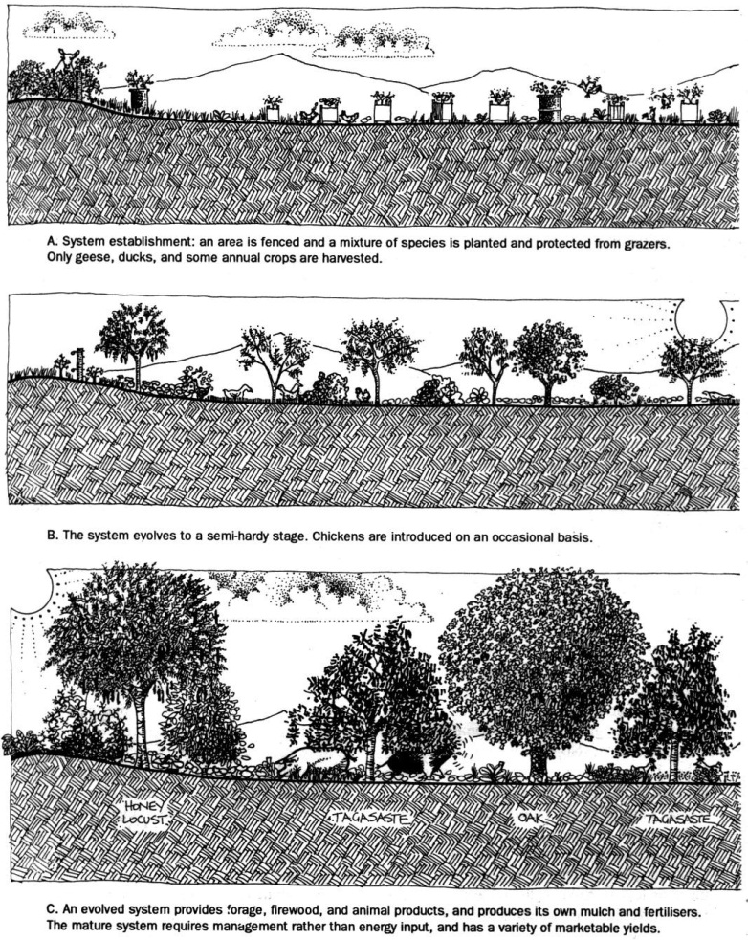

**Evolution of a Designed System**

Mollison and Slay, 1991, *Introduction to Permaculture*, p.23, fig.1.10

A: System Establishment: an area is fenced and a mixture of species is planted and protected from grazers. Only geese, ducks, and some annual crops are harvested.

1. **Use what is already growing**, usually a weed layer, to build soil fertility. Soft weeds can be sheet mulched with cardboard and old carpet, or slashed and used as mulch around other plants before seed heads develop.
2. **Introduce plants that will easily survive** in the particular environment and which will help to bring up soil fertility. Depending on the types of soils we are working with we can plant both annual and perennial types of a locally-adapted legume (for green manure and mulch), and shrubby useful perennials known to survive and thrive. We may need to wait to plant our own ‘climax’ crops until more favourable soils are established.
3. **Raising organic levels artificially** by using mulch, green manure crops, compost and other fertilisers to change the soil environment. This enables us to plant more quickly, or, if used in combination with the previous method, to plant a nucleus of climax tree crops in marginal ground if we are willing to put in the work of caring for those trees.
4. **Substituting our own herb, pioneer, and climax species** which are more useful to us than the existing natural or disturbed vegetation. Comfrey, for example, will come up through weed growth, helping to control the area if planted densely enough, and providing yields in the first year.

(Mollison and Slay, 1991, *Introduction to Permaculture*, p.22-24)

**12. Principle of Accelerated Succession**

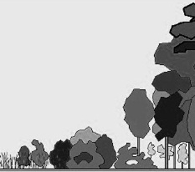

B: The system evolves to a semi-hardy stage. Chickens are introduced on an occasional basis.

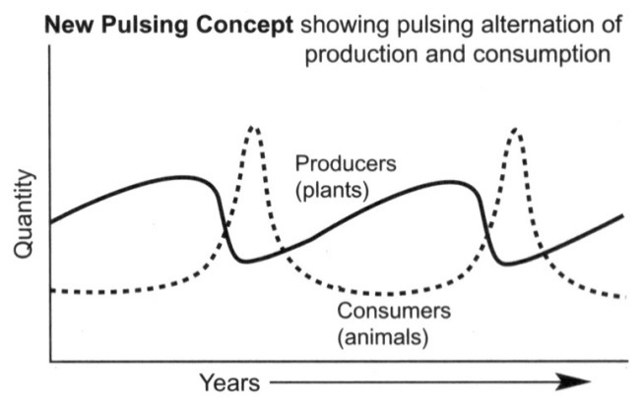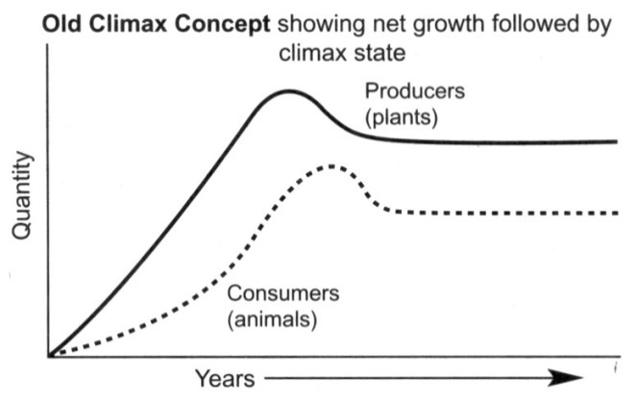

C: An evolved system provides forage, firewood, and animal products, and produces its own mulch and fertilisers. The mature system requires management rather than energy input, and has a variety of marketable yields.

**Be aware and pulse with care**

“Ecological theory since the 1960s has begun to recognise that many ecosystems are evolved to go through periodic disturbance as part of an overall dynamic stability…These pulsing ecosystems typically develop a pattern of long, slow accumulation of biomass (production) followed by a short intense pulse of consumption where total biomass falls rapidly and nutrients are recycled…*The use of fire, grazing and cultivation to provide a pulse of high yield between longer phases of biological rebuilding can be recognised as strategic use of change against a background of catching and storing energy*.” However…pulsing the system too frequently leads to a downward spiral of land degradation...which permaculture is trying to reverse through a fundamental redesign of agriculture and land use.”

Holmgren, 2002, pages 248-254

**H12. Creatively use and respond to change.**

“*Vision is not seeing things as they are but as they will be”.*

We can have a positive impact on inevitable change by carefully observing, and then intervening at the right time.

**H4. Apply self-regulation and accept feedback**:

*“The sins of the fathers are visited on the children of the seventh generation.”*

We need to discourage inappropriate activity to ensure that systems can continue to function well.

**PRINCIPLES**

**Mind-map 12.**