*A Pattern Language* (Alexander et. al. 1977) looks at the design of human dwelling areas, from homes to towns, and presents a number of ‘patterns’ for designers to follow based on ‘natural’ human behaviour. For example, balconies less than 2 metres deep are hardly used.

**NATURAL COOLING**

Ergon reports that 49% of the household power use in Townsville is for air conditioning. Using natural forces to heat and cool a home is crucial if moving to a low energy usage future.

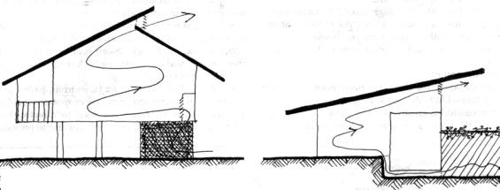

CROSS VENTILATION: Vented ceiling slopes allow hot room air to escape, and cool trellis air to enter (*Designers’ Manual*, Fig. 10.16)

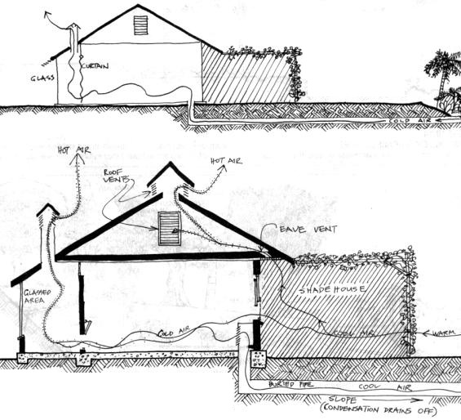

COOL AIR FROM SHADEHOUSE AND BURIED PIPE: a 0.5 X 0.5 m tunnel 1 m deep and 20 m long sloping to the outside intake to dehumidify and cool equatorial air, with a solar chimney to draw air through the house. (*Designers’ Manual*, Fig. 10.17, p. 264)

Permaculture is based on “…a philosophy of working with rather than against nature; of protracted and thoughtful observation rather than protracted and thoughtless action; of looking at systems and people in all their functions rather than asking only one yield of them; and of allowing systems to demonstrate their own evolutions.” Mollison (1988) *Permaculture: A Designers’ Manual,* p.3.

**Work with nature, rather than against the natural elements, forces, pressures, processes, agencies, and evolutions, so that we assist rather than impede natural developments.**

**13. Principle of**

**Natural Forces**

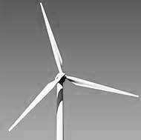

**ORCHARD**

One way to apply the principle of natural forces to your orchard area is to incorporate ‘useful’ native species local to your region, and by using a planting pattern similar to local ecosystems. For example the following planting pattern is based on *vine rainforest* found in the Townsville / Thuringowa region, with species from both local *vine rainforest* and *eucalypt and acacia woodland* ecosystems interplanted with introduced plants.

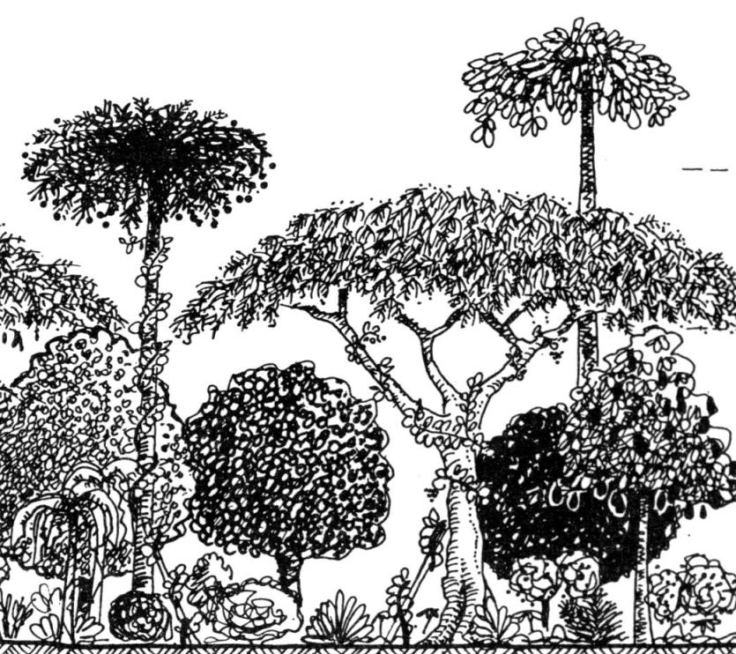

UPPER STOREY:

White fig - fruit

White cedar – insecticide

Burdekin Plum - fruit

----------------------------

MID: THIN FOLIAGED LEGUMES,

FRUIT/NUTS

Native white mulberry - fruit

Peanut tree – edible seed

Cocky Apple -fruit

Townsville wattle, toothed wattle, Silver wattle, Sim’s wattle (all local) – legumes

----------------------------

LOWER: FRUIT/NUTS:

Coffee, pineapple, ginger, cassava, sweet potato, etc.

ADD: native jasmine and mat rush (edible flowers, stalk)

+

**“In designing with nature, rather than against it, we can create landscapes that operate like healthy natural systems, where energy is conserved, wastes are recycled and resources made abundant” (Mollison 1991, p. 72).**

**H1. Observe and interact**

*“Beauty is in the eye of the beholder”*

By taking the time to engage with nature we can design solutions that suit our particular situation.

**H12. Creatively use and respond to change**.

*“Vision is not seeing things as they are but as they will be.”* An understanding of natural forces and cycles can assist us in creatively responding to change.

**PRINCIPLES**

**Mind-map 13**

**8.**