*“The first priority is to survive (obtain a* ***yield*** *from captured energy, while the second is to pay for what we get in some way that helps maintain the future flow of energy”.* Holmgren 2002:75

**The Role of Life in Yield:**

Living things, including people, are the only effective intervening systems to capture resources on this planet, and to produce a yield. Thus, it is the sum and capacity of life forms which decide total system yield and surplus.

**The yield of a system is theoretically unlimited**

**The only limit on the number of uses of a resource possible within a system is in the limit of the information and the imagination of the designer.**

It is interesting to note that Ross Mars, permaculture teacher and author, states : “While yields in a permaculture system can be high, much higher than natural bush or forest areas, there is a limit, no matter how well we design and how ingenious we are. Plants and animals have limits to their growth and production.” Mars (2003) *The Basics of Permaculture Design*, p.3.

**Yield** is not a fixed sum in any design system. It is the measure of the comprehension, understanding, and ability of the designers and managers of that design.

**H3. Obtain a Yield**

“You can’t work on an empty stomach”.

Growing gardens of “useful” rather than “useless” ornamentals was a part of the early popularisation of permaculture. The historical spread of ornamental gardens in the industrial era was a “nouveau riche” cultural statement about wealth that implied food gardening was only for peasants.

**BANANAS:**

Bananas thrive in Townsville’s climate as long as additional water is provided. They are a great addition to any tropical garden as they bear fruit in the first year. In a home garden situation when you harvest a bunch of bananas you are usually left with too many ripe bananas to eat before they rot. One way to expand the yield to only harvest a single hand off the bunch at a time. The ones harvested will ripen much faster than those left on the bunch. Another way is through preserving, drying, or freezing. Sun dried bananas will last a fair while and are good chewy snacks. Another way is to make banana ice-cream. Peel the bananas before freezing then put them through a good quality juicer (e.g. Champion) and they come out like soft-serve ice cream. This can also be used as a base (mixed with other frozen fruit and put in an ice cream maker) for a non-dairy no added sugar ice cream that is 100% fruit.

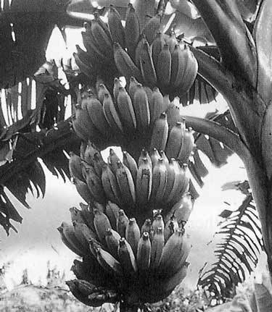

ie4

**14. Principle on Yield**



**Solar food dryer**

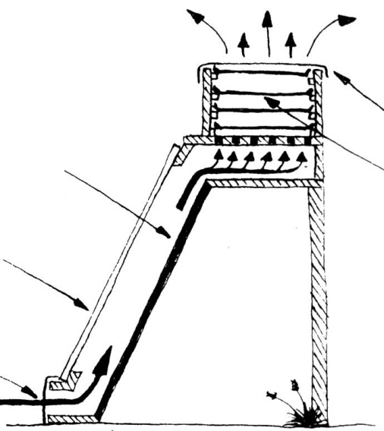

**Definition of System Yield:**

System yield is the sum total of surplus energy produced by, stored, conserved, reused, or converted by the design. Energy is in surplus once the system itself has available all its needs for growth, reproduction, and maintenance.

From: Mars, R. (2003) *The Basics of Permaculture Design*

flywire cover

drying trays

clear glass or plastic

flywire cover

black painted surface

**PRINCIPLES**

**Mind-map 14**

**8.**

**Dispersal of Food Yield over Time:**

• By selection of early, mid and late season varieties.

• By planting the same variety in early or late ripening situations.

• By selection of long-yielding varieties.

• By a general increase in diversity in the system, so that leaf, fruit, seed and root are all product yields.

• By using self-storing species such as tubers, hard seeds, nuts, fuel wood, or rhizomes which can be '"cropped on demand'".

• By techniques such as preserving, drying, pitting, freezing, and cool storage.

• By regional trade between communities, or by the utilization of land at different altitudes or latitudes.