For a community garden or community market garden to succeed takes the cooperation of the whole community. Waste food and other available organic inputs need to be collected and processed, This need to be applied as fertiliser on a range of crops with other organic inputs such as mineral rock dust where needed. At the garden you need people harvesting the food, collecting seeds from the largest fruits and vegetables, mixing up potting mix from worm compost and sand etc., planting and watering the seeds, and planting seedlings in the garden. The garden also needs to be irrigated and mulched regularly and checked for pests and diseases. The produce needs to be packed and delivered to either a store or direct to the end user. In these processes, from seed to plate, we rely on cooperation within the group managing the garden area and between the group and the community. The entire process also relies on the cooperation of billions of organisms and bacteria, necessary for the recycling of organic matter back into soil and plant nutrients. Soil bacteria and fungi (mycorrhiza) work together to feed minerals to the plants, and in return the plants feed sugars to the fungi. Both nature and human societies rely on cooperation for their correct functioning. When competition dominates in the garden one weed species can overwhelm and supress the natural diversity. When competition dominates in society one ‘cultural viewpoint’ can overwhelm and supress the myriad of subcultures that give societies their diversity and stability. In a diverse society where these subcultures are allowed to flourish alongside the main ‘crop’ there is a niche for everyone, leading to a rich and resilient culture.

**Cooperation, not competition, is the very basis of existing life systems and of future survival.**

While the majority of societies are based on cooperation, over the past few hundred years ‘Western civilisation’ has prioritised competition over cooperation. This is especially evident in their financial and economic systems. While a ‘renaissance person’ could have a wide grasp of many disciplines, since the 1800s there was has been a scientific tradition of ‘reductionism’ which has led to a splintering and separation of many disciplines. In the 1960s and 1970s a more inclusive and holistic way of looking at life and the world around us began to emerge. Permaculture was at the forefront of this ‘movement’, advocating the integration of many disciplines into the design process. The following is from Mollison (1988) *Permaculture: A Designers’ Manual*, pp.1-2.

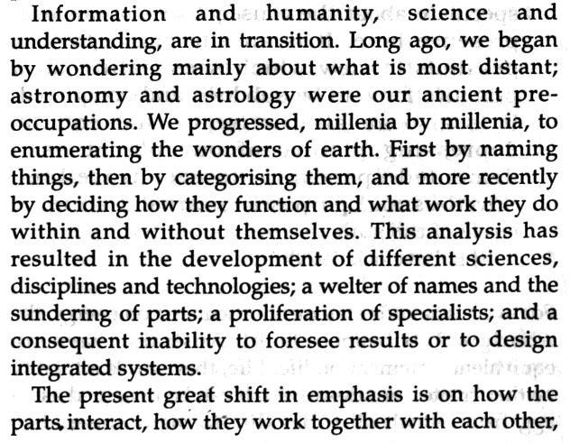

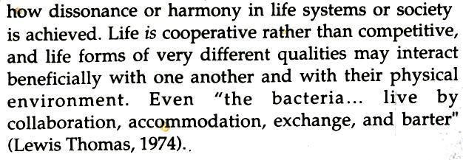

**15. Principle of**

**Cooperation**



The term ‘survival of the fittest’ was first used by an American economist, Herbert Spencer, in 1864. Darwin did later use the term, but a more accurate description of his theory of natural selection is **‘‘survival of the best fi**t’. He did not intend it to mean that the most competitive species or organism ‘wins’. He theory of natural selection is that those organisms survive that are **“better designed for an immediate, local environment.”**

See GUILDS under **PRINCIPLE OF STABILITY**,

**PRINCIPLES**

**Mind-map 15**

**8.**

During the 1960s/1970s there was an emphasis on ***self-sufficiency*** amongst some sub-cultures. This entailed growing and producing as much of your needs as possible. In contrast Permaculture stresses ‘***self-reliance’***. We are all part of a society and it is through cooperative behaviour within that society that we can become self-reliant. Rather than demanding of the land you are on to produce all your needs, see what your land wants to produce in excess and swap or sell that to others. Also see what you ‘naturally produce in excess’ (i.e. what you specialise in) and share those skills with others.

