“It is only how we see things that make them advantageous or not (if a wind blows cold, let us use both its strength and its coolness to advantage). A corollary of this principle is that everything is a positive resource; it is just up to us to work out *how* we may use it as such.” (Mollison, 1988:35)

Within traditional agricultural systems weeds are considered a problem to get rid of. In permaculture weeds are a resource (i.e. the problem is the solution). A major ‘weed problem’ in the Townsville / Thuringowa region is Chinee Apple (*Ziziphus mauritiana*). This would not be a problem if you want to raise goats, but would rather be a hardy self-reliant species suitable for browsing.

The following extract is from *Introduction to Permaculture* (Mollison 1991:30).

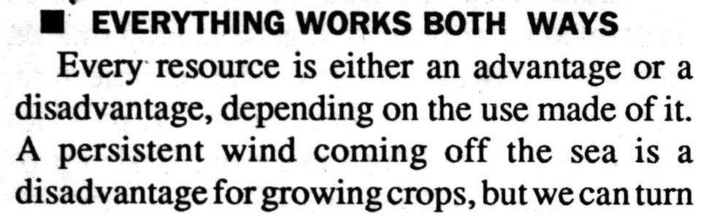

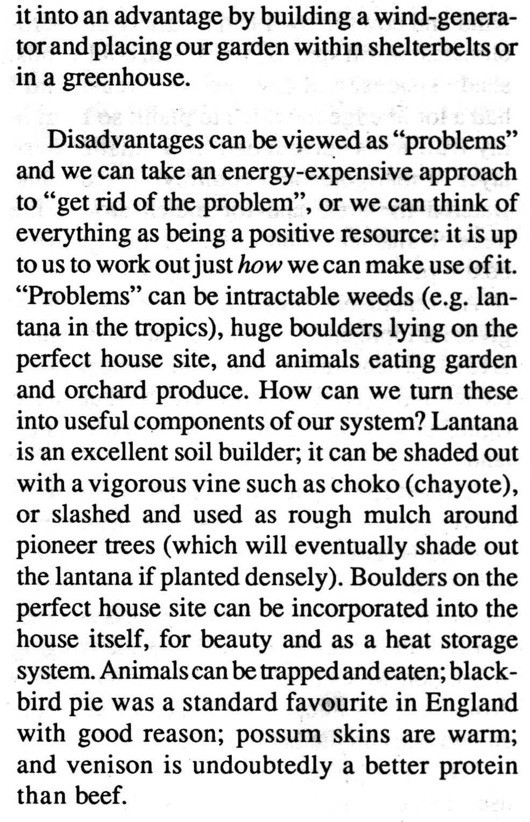

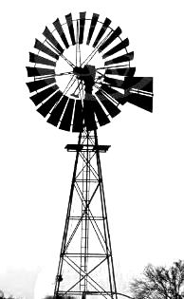

Weeds are a useful resource when accelerating succession and evolution (see **Principle of Accelerated Succession**). Fast growing weeds can be slashed and used as mulch or composted to increase soil fertility and smother new weeds.

Weeds can be an indicator of nutrient deficiencies in the soil. For example bracken grows in acidic soils low in fertility.

**The problem is the solution;**

**Everything works both ways.**

**A heat pump works both ways…**A heat pump for heating water works like a refrigerator in reverse. Warm air enters, the heat is transferred to the water, and then cold air is expelled. In Japan heat pumps are available where the cold air is used for air conditioning. In contrast, in Australia this cold air is usually vented outside and wasted.

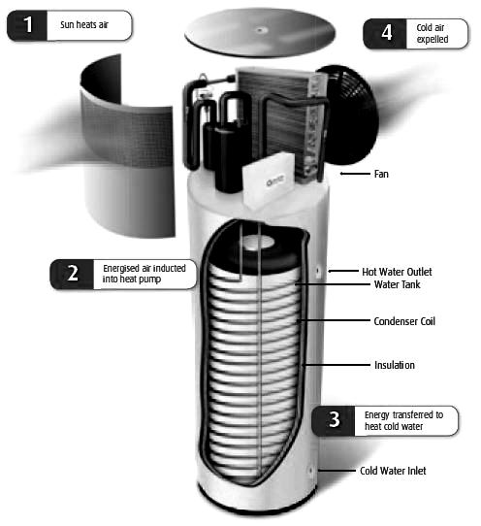

**16. Positivity Principle**



**H1. Observe and Interact**

*“Beauty is in the eye of the beholder”*

By taking the time to engage with nature we can design solutions that suit our particular situation.

Think of one current waste product in your household that could be used as a resource ………………………………………………………………………………………………………………………………………………………………………………………………………………

Think of a ‘problem’ in your own life that could be turned into a positive

…………………………………………………………………………………………………………………………………………

……………………………………………………………………

**PRINCIPLES**

**Mind-map 16**

**8.**