**Grow food where people live;**

**Bring food production back to the city.**

**Principle Origin**: Although this is not expressly stated as a ‘principle’ in either *Permaculture: A Designers’ Manual* or *Introduction to Permaculture* it is central to permaculture philosophy and ethics. “Permaculture aims to bring food production back to urban areas, and to redesign or retrofit buildings to save and generate their own energy, using well-known energy-saving strategies and techniques of appropriate solar design for climate, weather-proofing, wind-power, trellis, insulation, low-cost transport, and cooperative power generation” (Mollison 1991, p. 171). It is listed as a principle by a number of practicing permaculture teachers such as Michel and Jude Fanton in *The Seed Savers Handbook* (1991, p.43) and Rosemary Morrow in *Earth Users Guide to Permaculture* (1993, p.12).

**“Guerrilla gardening** is gardening on land that the gardeners do not have legal right to use, often an abandoned site or area not cared for by anyone. It encompasses a very diverse range of people and motivations, from the enthusiastic gardener who spills over their legal boundaries to the highly political gardener who seeks to provoke change through direct action. The land that is guerrilla gardened is usually abandoned or neglected by its legal owner. That land is used by guerrilla gardeners to raise plants, frequently focusing on food crops or plants intended to beautify an area. This practice has implications for land rights and land reform; it promotes re-consideration of land ownership in order to reclaim land from perceived neglect or misuse and assign a new purpose to it.

Some guerrilla gardeners carry out their actions at night, in relative secrecy, to sow and tend a new vegetable patch or flower garden in an effort to make the area of use and/or more attractive. Some garden at more visible hours to be seen by their community. It has grown into a form of proactive activism or pro-activism.”

<http://en.wikipedia.org/wiki/Guerrilla_gardening>

**Guerrilla gardening networking page:**

<http://guerrillagardening.org/community/index.php?board=29.0>

**Guerrilla gardening Facebook page:**

<www.facebook.com/guerrillagardening>



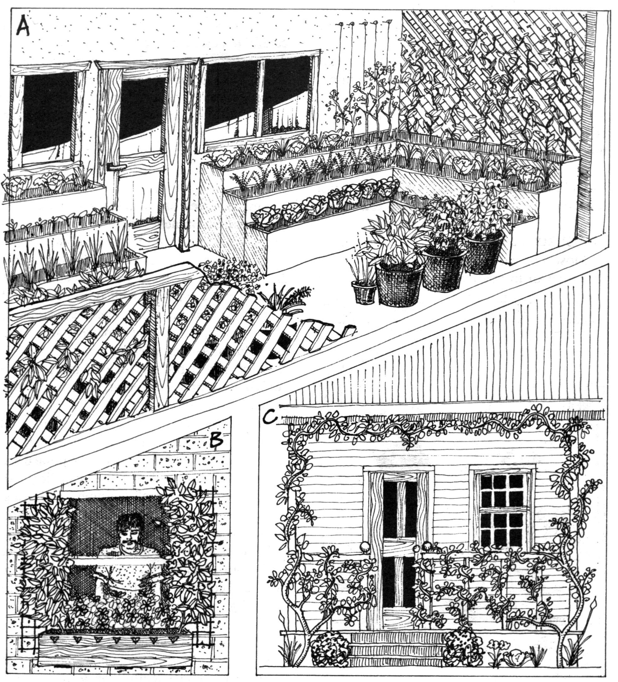

A. cut-away view of a patio set up for herb, vegetable, small fruit in beds or pots. B. Outside window box and trellis. C. Verandah trellis for shade and fruit.

From: *Introduction to Permaculture*, p. 108, fig. 5:15.

**17. Proximity Principle**



**Verge gardening** (growing on the side of the road) is carried out both as an illegal guerrilla gardening pastime, and as a legal community activity.

**Farmers Markets** are where the local farmers and food producers sell to the public. **Buy Local**

**The Future? - Vertical Farming**

<http://en.wikipedia.org/wiki/Vertical_farming>

<www.verticalfarm.com/>

**City farms**, or ‘market gardens’ were once a feature of every city. Larger growing sites in urban areas are now more likely to be community gardens.

**Cities as farms** – is the planting of ‘useful’ species along roadsides and in parks. The produce could be harvested by local non-profit organisations to raise revenue. Councils are usually against the planting of fruit and nut trees in public areas due to upkeep.

**Community gardens** are places where people come together to grow fresh food, to learn, relax and make new friends. The Australian City Farms and Community Gardens Network connect community gardeners around Australia. It is an informal, community-based organisation linking people interested in community gardening across Australia. <http://communitygarden.org.au/>.

NOTE: See also Principle of Cooperation

**H9. Use small and slow solutions.**

*“The bigger they are the harder they fall.” “Slow and steady wins the race.”*

Small and slow systems are easier to maintain than big ones making better use of local resources and produce more sustainable outcomes.

**PRINCIPLES**

**Mind-map 17**

**8.**