When designing your system you will need to draw on information from a variety of sources. The Permaculture Tree gives a clear pictorial representation of the many disciplines Permaculture aims to combine into a holistic design. Don’t be daunted though as you can start with what you already know, just like starting at the kitchen door and working your way out from there. The important message from this principle is not just to collect information but to put that knowledge into action. This is especially crucial when teaching, as actions always speak louder than words.

**H1. Observe and interact**

*“Beauty is in the eye of the beholder”*

By taking the time to engage with nature we can design solutions that suit our particular situation.

**Backyard Permaculture Techniques**

* swales
* herb spirals
* keyhole beds
* wicking beds
* banana pits
* mulching
* composting
* raised beds
* trellises
* natural insecticides
* organic growing

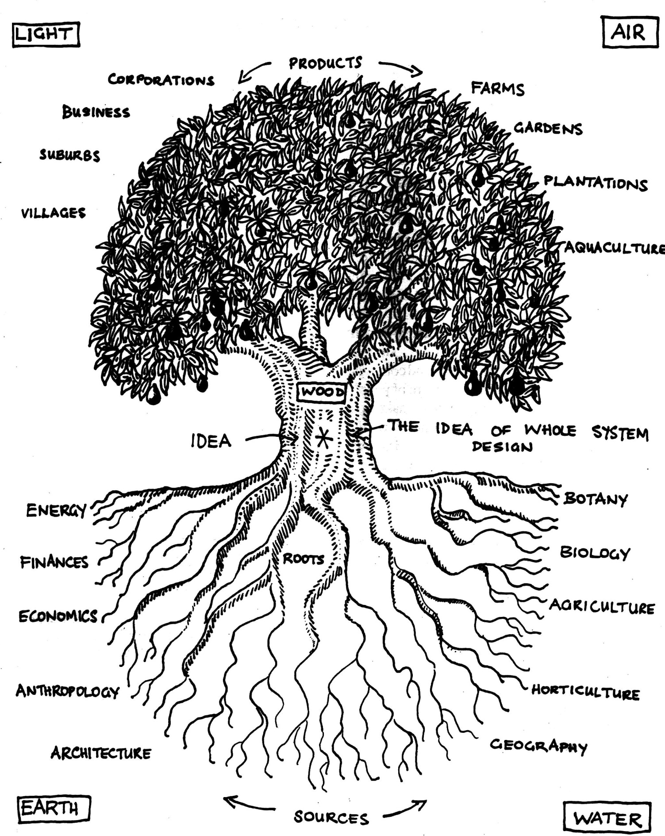

**THE PERMACULTURE TREE**

“The Permaculture Tree, the elements of design. Roots are in many disciplines, an abstract world. Products lie in the real world. The germination of an idea translates in formation into product. (The five elements; wood, fire (light), earth, air, water, are organised by a tree, as information is organised by ideas).’’ Adapted from Mollison (1991) *Introduction to Permaculture* p.4.

**Housing**

* passive solar, aspect
* power & water systems
* natural ventilation
* non-toxic materials
* integration with garden

**18. Demonstration is Authority Principle** 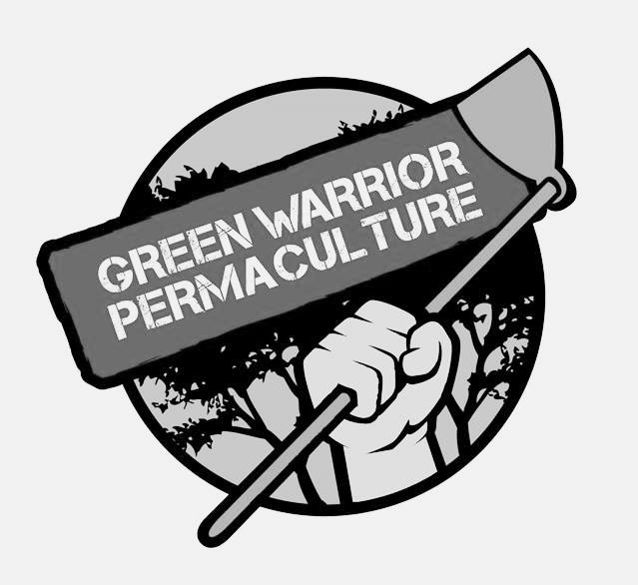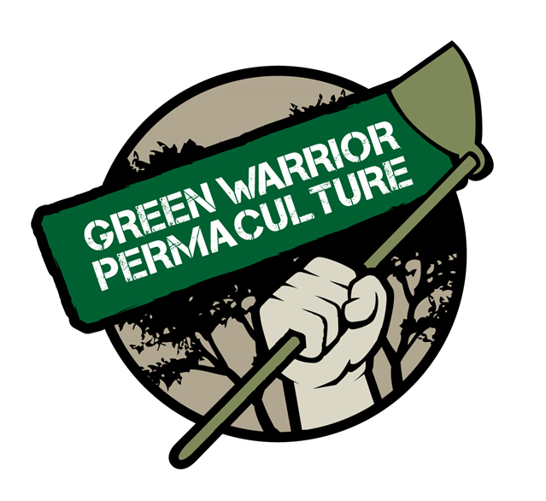

**Local Conditions**

* climate
* mesoclimate
* microclimates
* rainfall
* winter/summer sun
* wind patterns
* soil types

ECOLOGY

AQUACULTURE

URBAN PLANNING

GEOGRAPHY

HORTICULTURE

AGRICULTURE

BIOLOGY

BOTONY

ARCHITECTURE

ANTHROPOLOGY

ECONOMICS

FINANCES

ENERGY

GEOLOGY

* **Animals**
* species: e.g. chickens, ducks
* breeds: e.g. Muscovy, Indian runner, Campbell (ducks)
* uses: e.g. tractor system
* needs: e.g. food species

SOCIOLOGY

* **Bill Mollison’s** **Principles** <www.permaculturefundamentals.org>
* **David Holmgren’s Principles**, <www.permacultureprinciples.com/>
* **Permaculture Australia** <permacultureaustralia.org.au/>
* **Permaculture Research Institute** <www.permaculturenews.org/>
* **Online resource reader** <treeyopermacultureedu.wordpress.com/>

**Indigenous Knowledge**

* species and techniques.
* sustainable land practices
* land ‘ownership’

**Local Sources**

* seeds
* plants
* mulch
* potting mix
* garden supplies

**Information is *the* critical potential resource. It *becomes* a resource only when obtained and acted upon.**

**Local Groups**

**Magazines**

**Books**

In Australia the government CSIRO Publishing <www.publish.csiro.au/> is a great online source for books on a wide range of ‘permaculture-related’ topics, from agricultural science related topics to vegetable growing and garden design.

The main text books for the **Permaculture Design Certificate (PDC)** are **Permaculture: A Designers’ Manual** (Mollison 1988) and **Introduction to Permaculture** (Mollison & Slay 1991). Available from <www.tagari.com>

**PRINCIPLES**

**Mind-map 18**

**8.**

**Internet**

**Life experience**

BIOTECTURE

AGROECOLOGY