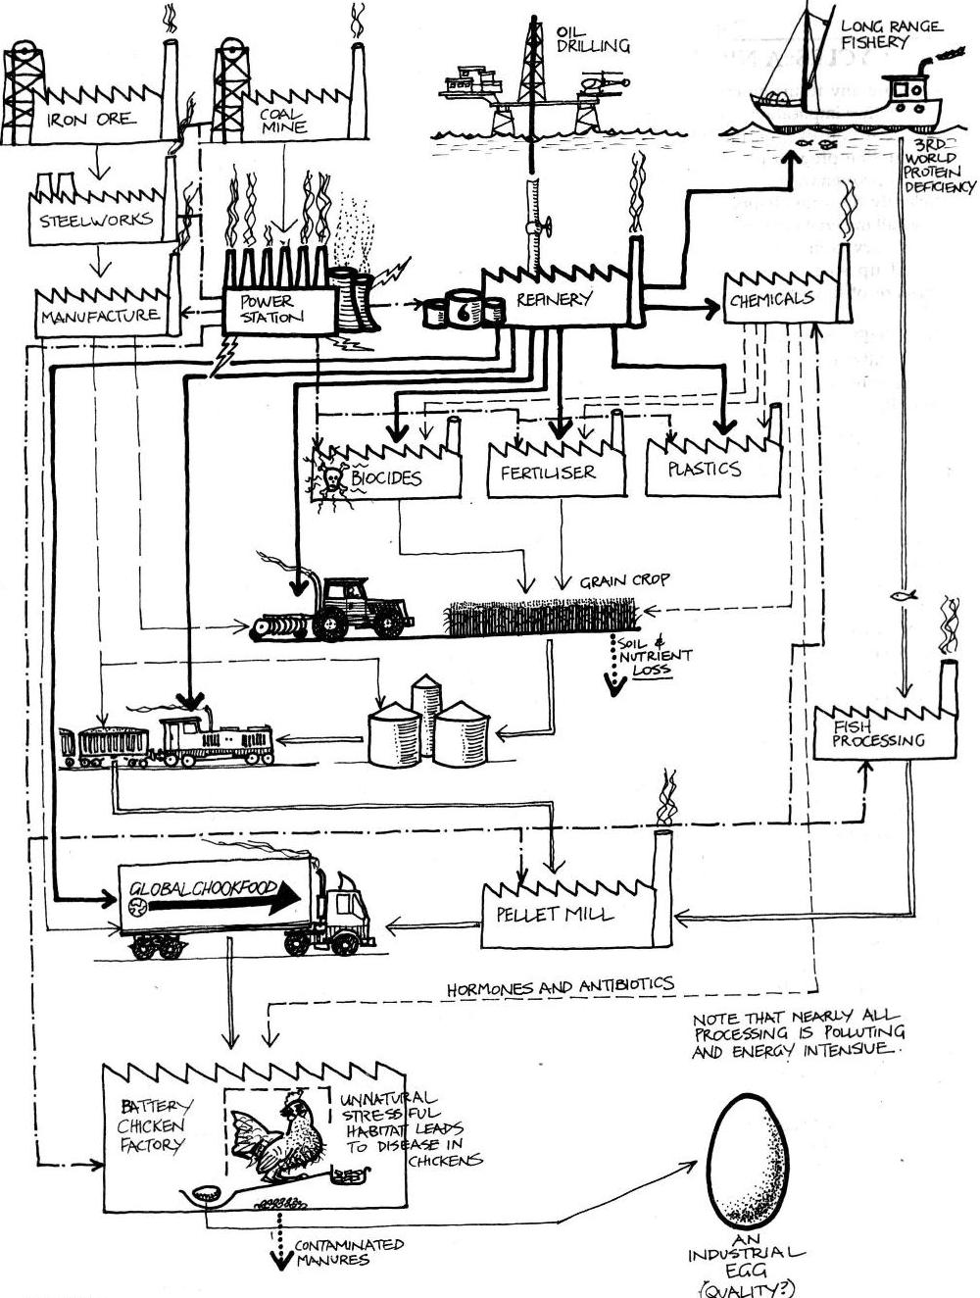

**INDUSTRIAL METHODS OF PRODUCING AN EGG**

From: *Permaculture: A Designers Manual*, p. 24, Fig. 2.3

Permaculture systems, fuelled by the sun, should produce both for their own needs and the needs of the people creating or controlling them.

The energy required to construct and maintain your system must be less than the energy it is able to store or conserve.

The sun is the major source of energy for life on this planet, and is the main energy source within permaculture systems. It produces wind, rain and biomass. Others sources are waste products with embodied energy

This diagram gives some idea of the energy inputs required to commercially produce an egg. The energy inputs are far greater than the food energy in the egg.

**1. Principles of Energy Inputs**



To minimise on-going energy inputs the systems we construct should last as long as possible and take least maintenance.

6. Work where it counts;

Don’t waste energy on unproductive work.

**PRINCIPLES**

**Mind-map 1.**

**H2. Catch and store energy.**

“Make hay while the sun shines.”

By developing systems that collect resources at peak abundance, we can use them in times of need.

5. Make the least change for the greatest possible effect.

Minimise your energy inputs by careful and protracted observation prior to action.

For example, don’t weed Chinee apple seedlings at the end of the wet as 90% of seedlings die in the dry season.

* reduced water use equals reduced energy inputs;
* increased use of home products reduces transport energy;
* encourage mycorrhizal relationships in order to lessen fertiliser inputs (e.g. use compost);
* make use of legumes and green manure crops;
* grow crops suited to the climate rather than trying to alter the conditions for the plant;
* reduce fossil fuel energy inputs (i.e. use hand tools where possible);
* install grid-connected solar power;
* install solar hot water or heat pump;
* retrofit your house to take advantage of natural cooling (e.g. attached greenhouse);
* install a rainwater tank;
* car pool or use public transport when possible;
* reduce your consumption of meat.