NOTE: **Keyline** systems move water from the gullies to the ridges using an off-contour method.

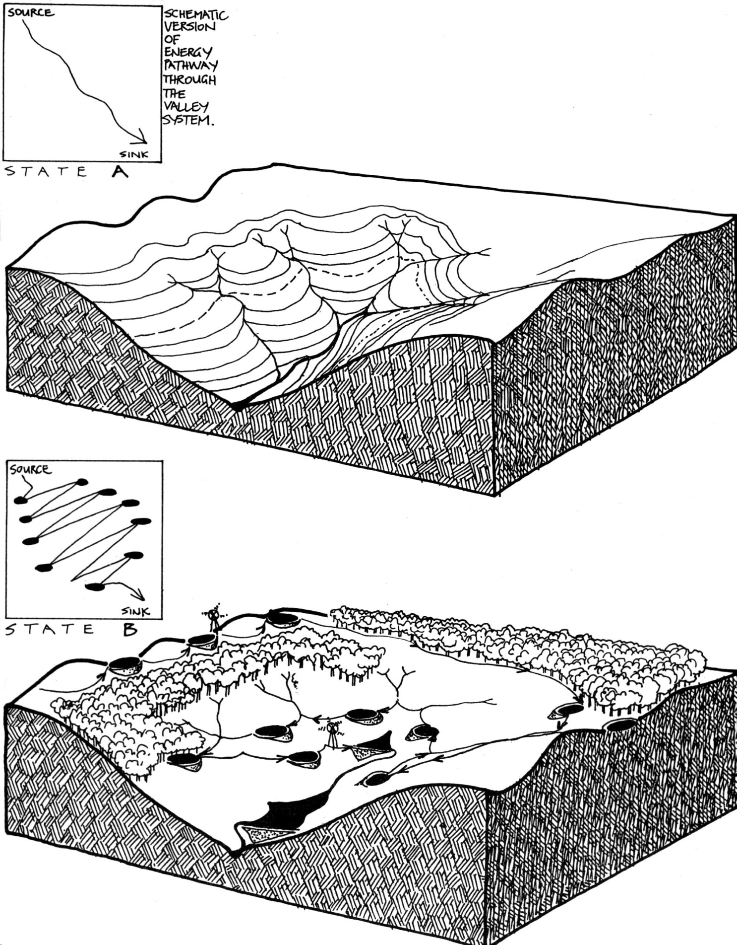

Be aware of the natural biogeochemical cycles (hydrological, carbon, nitrogen, potassium, etc.), and develop systems that assist rather than impede these flows.

**The Basic Laws of Thermodynamics**: All energy entering an organism, population or eco-system can be accounted for as energy either stored or depleted. Energy can be transferred from one form to another but it cannot be created or destroyed. It is a constant. No energy conversion system is every completely efficient. The total amount

of energy in the universe is constant and total entropy is increasing. “The second law of thermodynamics states that energy is constantly degrading, or becoming less usable to the system. It is through constant cycling, however, that life on earth proliferates. The goal of permaculture is to *catch, store, and use* everything before it has degraded to its lowest energy use and so is lost to us forever. Our job is to use incoming energy (sun, water, wind, manures) at its highest possible use, then its next highest, and so on. We can create use points from “source to sink” before it runs off our property.” Mollison, (1991) *Introduction to Permaculture*, p.19.

Return harvested nutrients to the garden (compost, mulch, etc.).

**Stop the flow of nutrients and energy off-site, and instead turn them into cycles.**

**2. Principle of Energy Cycling**



Kitchen wastes are recycled to compost; old newspapers are mulched; animal manures are directed to biogas production or to the soil; household greywater / blackwater flows to the garden; rain and runoff harvested; green manures are turned into the earth; leaves are raked around trees as mulch.

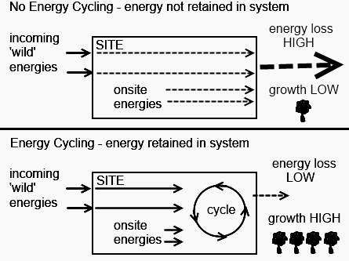

**H2. Catch and store energy.**

“Make hay while the sun shines.”

By developing systems that collect resources at peak abundance, we can use them in times of need.

**H6. Produce no waste.**

“A stitch in time saves nine.” - “Waste no, want not.”

By valuing and making use of all the resources that are available to us, nothing goes to waste.

**Every cyclic event increases the opportunity for yield. To increase cycling is to increase yield.**

The designer’s work is to set up useful energy storages in a landscape or building (going from State A to State B). Such storages become resources for increased yields.

From: *Introduction to Permaculture, p*. 18, fig. 1.8.

**PRINCIPLES**

**Mind-map 2.**

**The 5 Rs of waste minimisation**



**1. Resist**: Refrain from purchasing products surrounded in excessive packaging, choose green products, and use your own shopping bag rather than using the store’s plastic bags.

**2. Reduce**: Wherever possible, waste reduction is preferred to the following three options.

**3. Re-use**: If waste is produced, every effort should be made to re-use it if practicable.

**4. Recycle**: There are economic and environmental costs associated with waste collection and recycling, and should only be considered for waste that cannot be reduced or re-used.

**5. Recover**: Finally, it may be possible to recover materials or energy from waste that cannot be reduced, re-used or recycled.