**Sectors** deal with the wild energies, the elements of sun, light, wind, wildfire, and water flow (including flood). These all come from outside our system and pass through it. Possible sectors include; fire danger sector; prevailing winds; damaging winds; screening of unwanted views; winter and summer sun angles; and flood prone areas. Diagram from *Introduction to Permaculture*, p.13, fig. 1.5

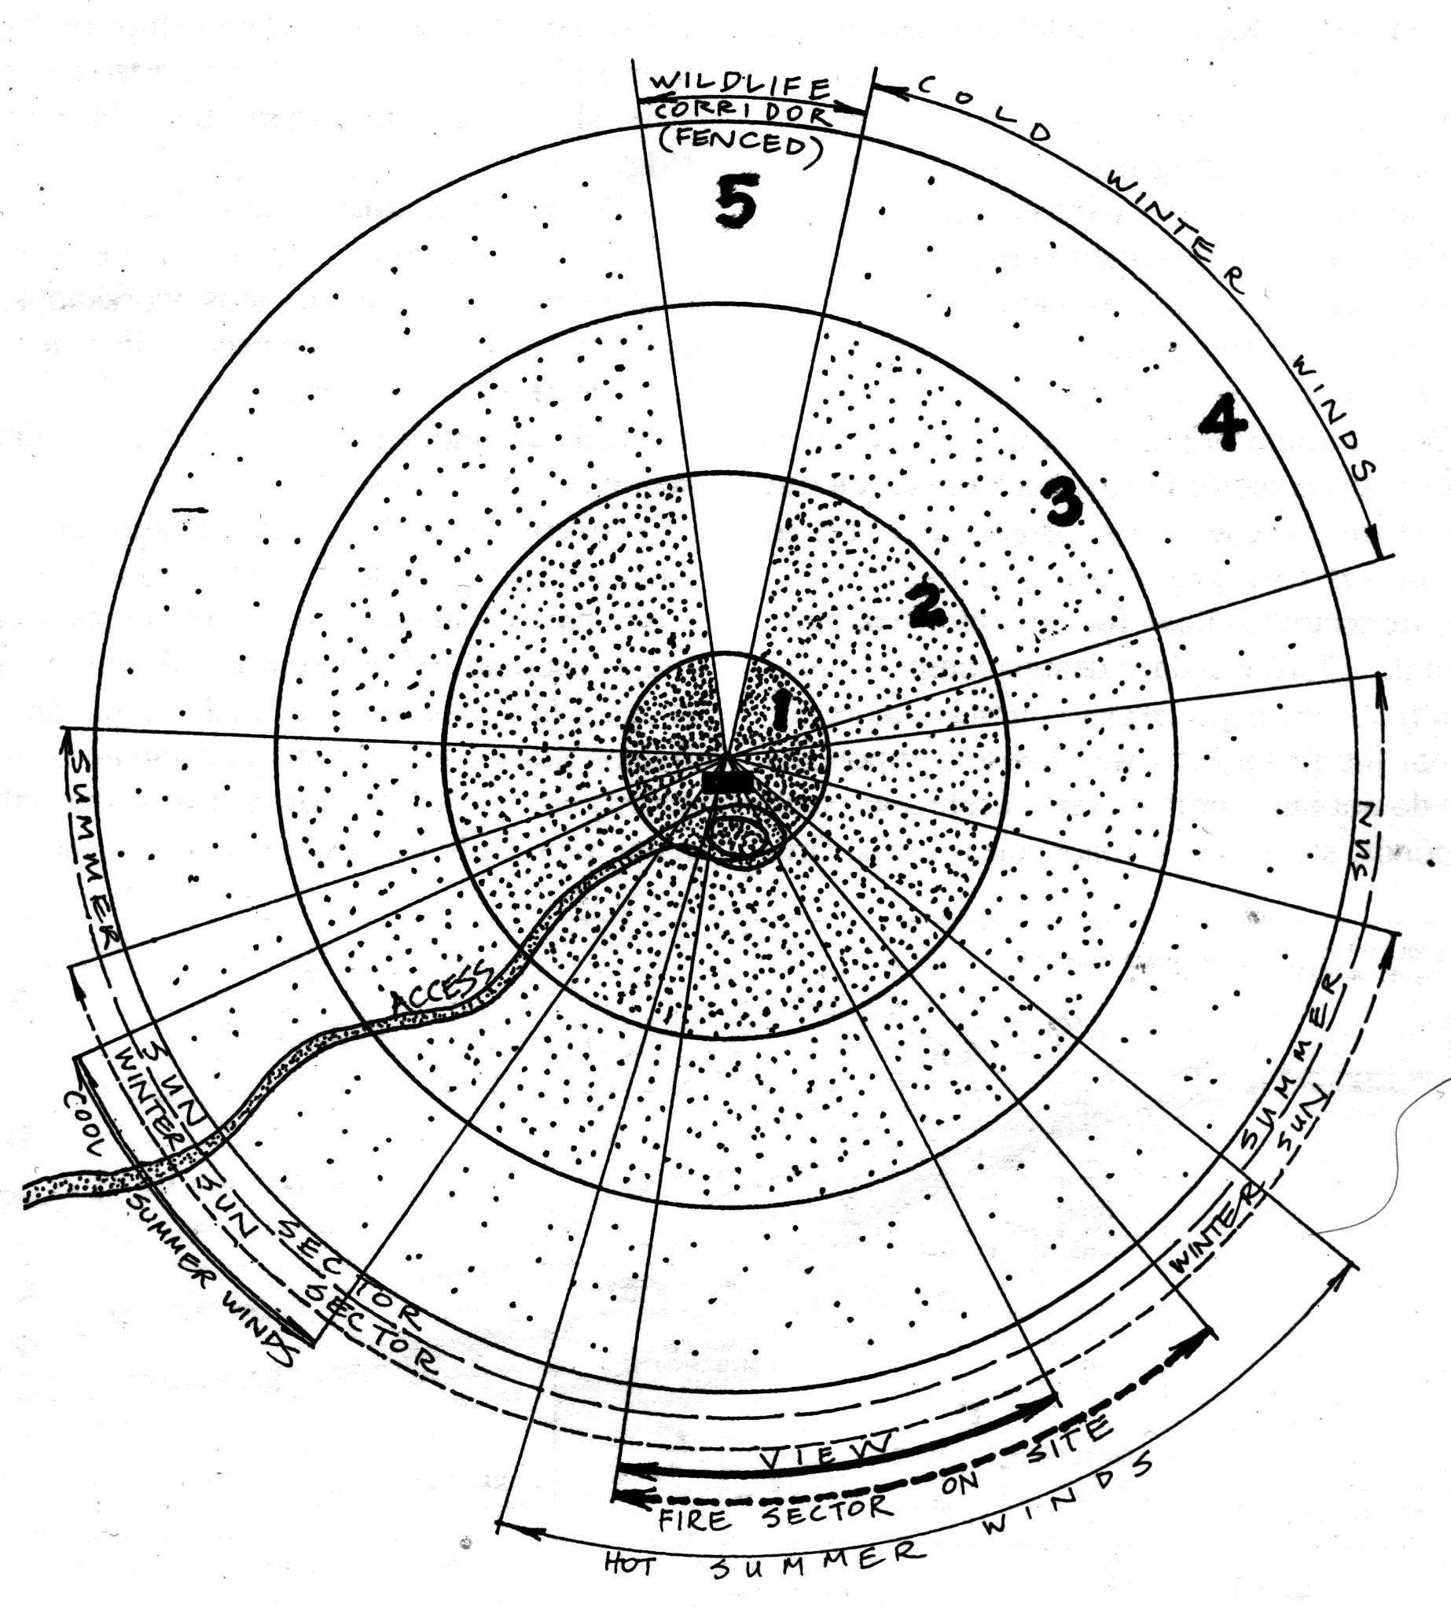

**Below are the sun sectors for the Townsville region:**

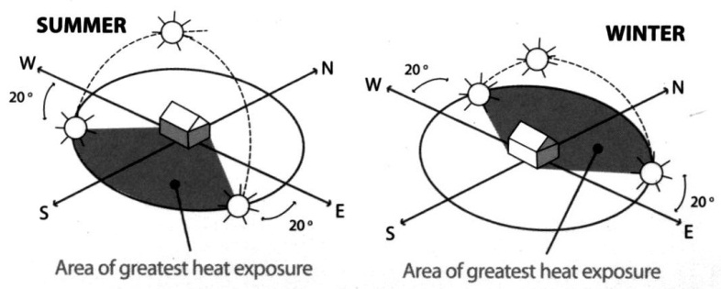

**Zone planning** means placing elements according to how much we use them or how often we need to service them. Diagram from *Introduction to Permaculture*, p.9, fig. 1.2. Table of Key Features from Mars (2003), *The Basics of Permaculture Design*, p. 20, table 3.2

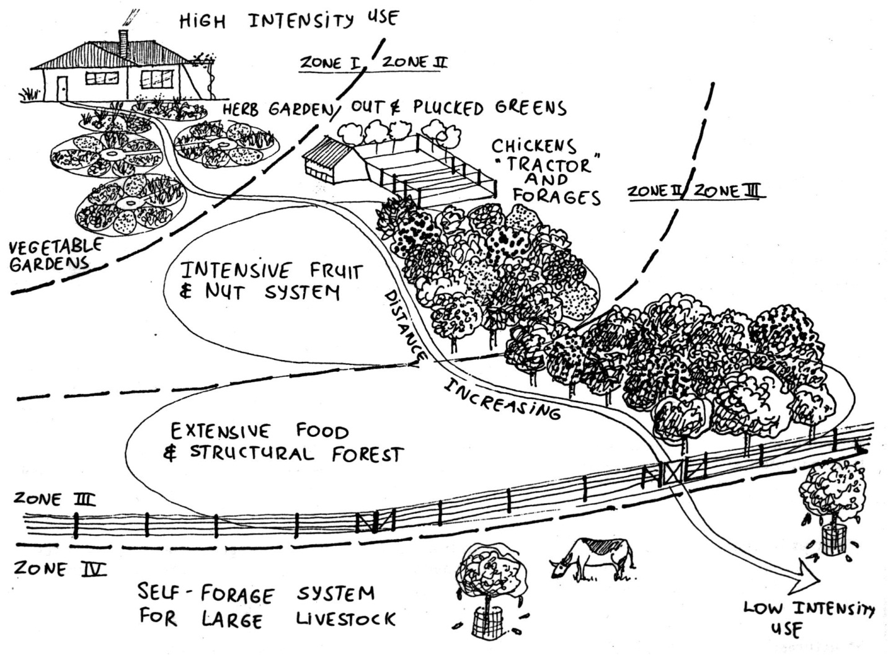

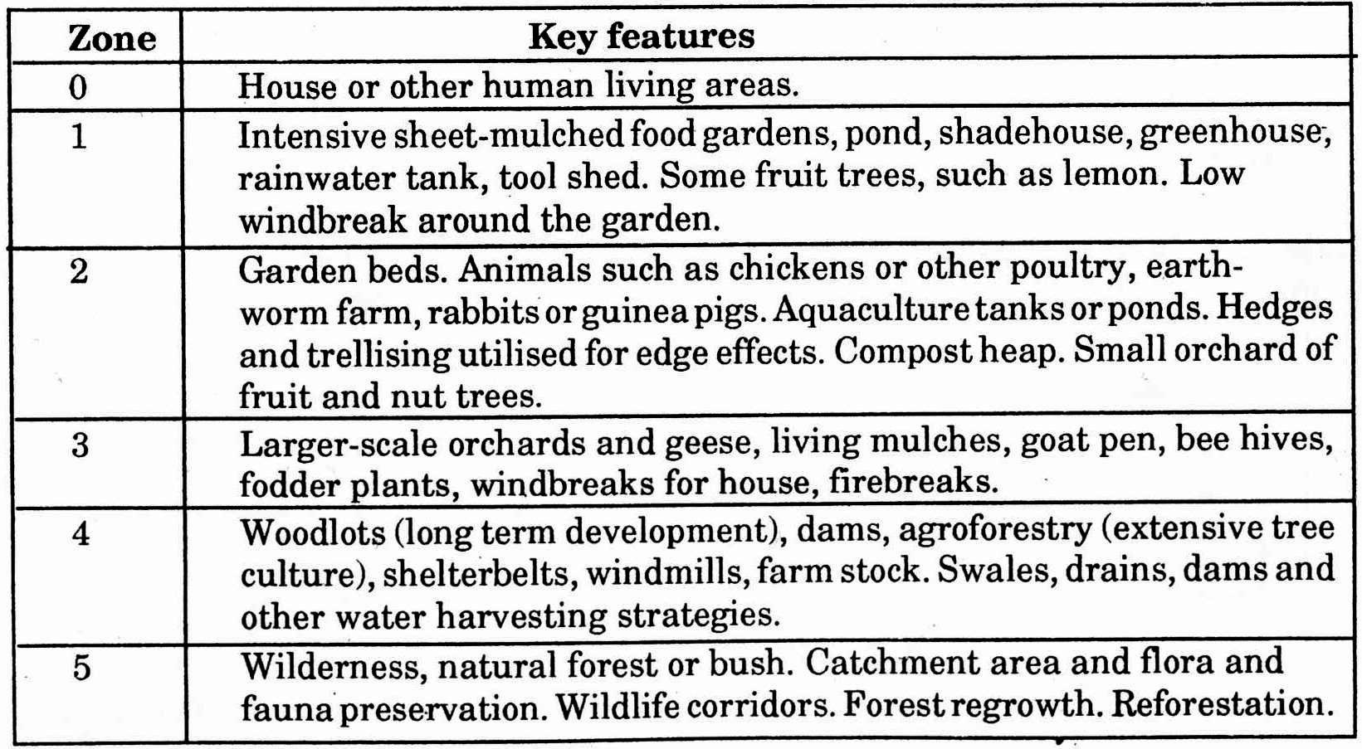

**The key to efficient energy planning is the zone and sector placement of plants, animal ranges, and structures.**

**3. Principle of**

**Efficient Energy Planning**



**Slope** is the third aspect to take into account with energy efficient planning. By examining the slope in profile we can identify best placement of such elements as dams, water header tanks, access roads, drains, flood or flow diversions, wastewater, and biogas units, etc. Through using slope to our advantage we can move water using gravity, and place elements so wherever possible we are moving mulch/compost downhill to our garden.

**H2. Catch and store energy.**

“Make hay while the sun shines.”

By developing systems that collect resources at peak abundance, we can use them in times of need.

**H7. Design from pattern to details.**

“Can’t see the forest for the trees”.

By stepping back, we can observe patterns in nature and society. These can form the backbone of our designs, with the details filled in as we go.

**PRINCIPLES**

**Mind-map 3.**