**Companion Planting** is the siting of plants in such a way as to benefit either one or both species. Plants to attract predator insects may be planted within or bordering a main crop. Scientific studies have been mixed, with some studies showing no effect or even a decline in yield. The best advice is to investigate then experiment. There is a lot of information in books and on the internet as a starting point.

**The “Aztec Sisters”**



Perhaps the most famous plant combination is the traditional method of planting corn, beans and squash together. This is sometimes known as the ‘Aztec Sisters’ or the ‘Native American’ method of planting corn. Timing is important if trialling a similar combination at home. First plant the corn, and when it is about 25 to 30 cm high plant the beans. Wait another two or three weeks then plant out the squash/pumpkin. The corn has to be mature enough not to get ‘swamped’ by the other plants. Try a combination of your own using corn or maize with any type of climbing bean and any type of cucurbit (squash, pumpkin, melons, etc.).

An **ecosystem** can be defined as a functional system of complementary relations between living organisms and their environment, delimited by arbitrarily chosen boundaries, which in space and time appear to maintain a steady yet dynamic equilibrium.

(Gliessman, 2007, *Agroecology*, p.23.)

**It is not the number of diverse things in a design that leads to stability, it is the number of beneficial connections between those components.**

**Levels of ecosystem organisation**

**applied to an agroecosystem**

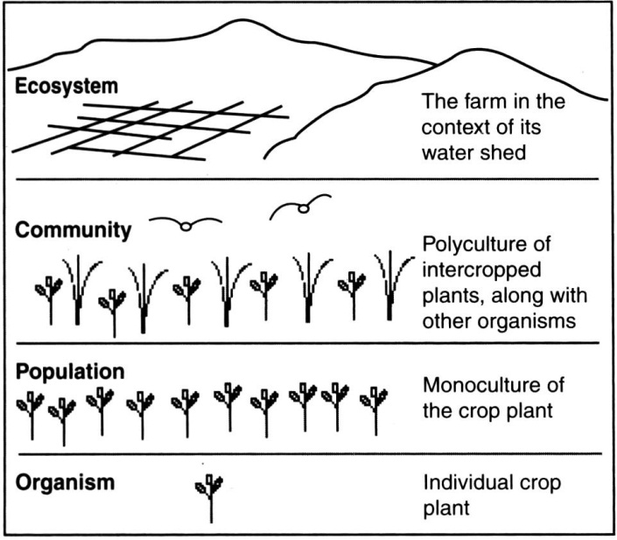

An agroecosystem mimics nature through developing beneficial connections between the various agricultural and support species. With a stable design there must be *beneficial* connections within each community of ‘useful’ plant species.

**4. Principle of Stability**

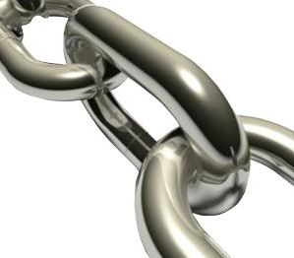

A **Guild** is an important term used in permaculture to describe a harmonious assembly of species clustered around a central element (plant, animal or structural). This assembly acts in relation to the element to assist its health, aid our work in management, or to buffer adverse environmental effects.

**CORN – BEANS - SQUASH**

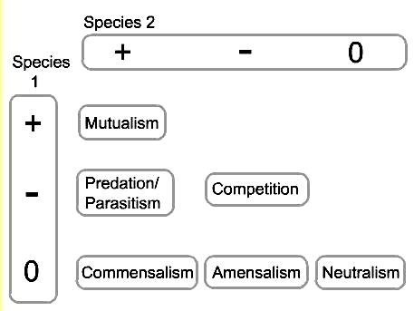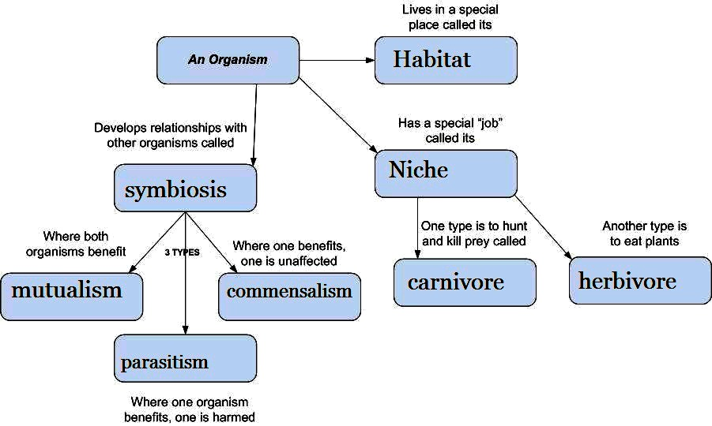

**+** signifies a positive reaction, **-** a negative reaction, and **0** no reaction.

**H8. Integrate rather than segregate:**

*“Many hands make light work.”*

By putting the right things in the right place, relationships develop between those things and they work together to support each other.

Stability in not only achieved through the correct placement of plant species. Of just as much importance is designing beneficial links between the non-biotic (non-living) components, and between the non-biotic and biotic components.

**PRINCIPLES**

**Mind-map 4.**