**Below are listed some of the uses and functions of trees within permaculture systems:**

**Pond**: Each element in the system should be chosen and placed so that it performs as many functions as possible. A **pond** can be used for irrigation, watering livestock, aquatic crop, and fire control. It is also a habitat for water fowl, a fish farm, and a light reflector. A dam wall functions as a road, a firebreak, and a bamboo production area.

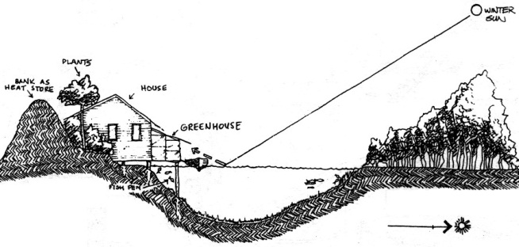

Ponds or dams as winter sun reflectors will increase dawn, evening, or winter heat on banks, benefiting vegetation (sun-facing banks are special ripening areas).

(From: *Introduction to Permaculture*, Mollison and Slay, 1991, p.41, fig. 2.8.)



**Environmental:**

* windbreak;
* fire control;
* erosion control;
* wildlife habitat (both alive and dead – e.g. dead hollow logs);
* climatic buffer,
* soil conditioner;
* cycles water via evapotranspiration;
* cycles deep nutrients;
* shades out some undesirable species;
* fast growing pioneers produce shade for other species;;
* berms/swales (dead trees on contour).

**Products:**

* fruits
* nuts
* edible seeds
* essential oils
* fuel
* timber
* biomass / mulch
* animal forage
* medicine
* O2

**FUNCTIONAL DESIGN:** Every component of a design should function in many ways.

**Each element serves many functions.**

**Structural**:

* privacy screen;
* trellis for vine crops;
* living fence;
* biotecture, etc.

**5. Principle of Multi-functionality**

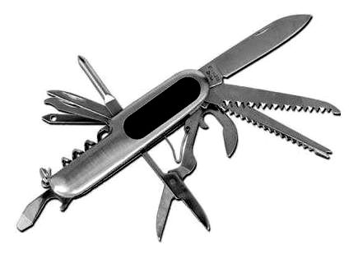

**Roofs:** primary function is for shelter but they can also be used for rainwater collection, solar panels, solar hot water systems, solar pool heating units, part of the ventilation system, outdoor living / growing space (roof gardens), roofs as gardens (‘green’ roofs which have a layer of growing medium at varying depth – some can only support a drought hardy herbage layer while some have the depth for shallow rooted trees).

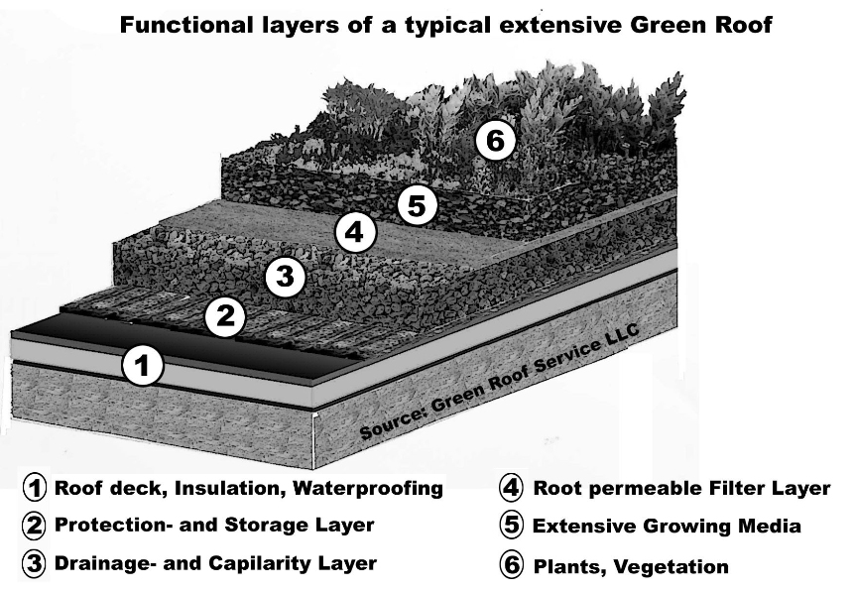

**Trees**: A windbreak can be made up of trees that provide fodder or sugar pods for cows (willow, honey locust, tagasaste, taupata, carob); coppice for kindling or firewood; give nectar and pollen for bees (e.g. *Acacia fimbriata*), and provide for their own nitrogen requirements (leguminous trees). Acacias fulfil many functions; they provide seed for poultry forage, foliage for larger stock, and fix nitrogen in the soil, while blossoms provide pollen for bees. They are also pioneer plants which prepare and protect the soil for slower growing, more sensitive plants. Selecting appropriate species requires a thorough knowledge of the animal or plant cultivar under consideration, its tolerances, its needs and its products. When considering plants, for example, we want to know:

* Is it deciduous or evergreen?
* Are its roots invasive?
* To what height does it grow?
* Is it fast growing and short lived or slow growing and long lived?
* Does it have a dense or light canopy?
* Is it disease resistant, or susceptible?
* Can it be browsed and cut, or will it die if over-pruned or coppiced?

(see also *Principle of Relative Location*)

**H6: Produce no waste.**

*“A stitch in time saves nine.”*

*“Waste not, Want not.”*

By valuing and making use of all the resources that are available to us, nothing goes to waste.

**H8: Integrate rather than segregate.**

*“Many hands make light work.”*

By putting the right things in the right place, relationships develop between those things and they work together to support each other.

**PRINCIPLES**

**Mind-map 5.**