**HOUSE**

**Water supply:**

* town supply;
* rainwater tanks;
* bores;
* creeks;
* run-off;
* dams / ponds;
* freshwater swimming pool.

**Energy:**

* grid-connected;
* grid-connected solar with back-up batteries;
* wind generator;
* back-up generator.

**Food:**

* purchases from shops/farmers market;
* mix of annual and perennial food plants;
* mix of leaf, fruit, seed and root crops;
* preserve surplus (dried, pickled, jams, chutneys, etc.).

**Fire;**

* fireproof cladding on house;
* clear area around house;
* fire retardant vegetation;
* pool / dam in fire ‘sector’;
* irrigated orchard;
* roads (access and fire breaks).

**Cyclone:**

* ‘Windworker’ plus floor and ceiling vents to equalise pressure;
* build above cyclone standards;
* no large eaves (greatest pressure area)
* cyclone rods where necessary;
* extra bolts holding window frame to house frame;
* no large trees close to the house.

In nature the decomposition of dead organic matter is critical to the cycling of nutrients. The diagram shows how this important function in nature is supported by many different elements.

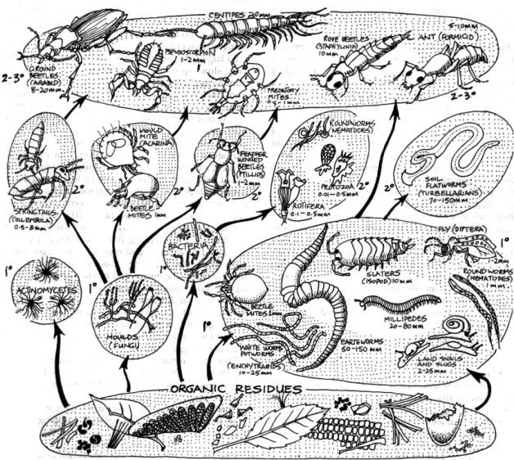

**Food web of a compost pile:** Energy flows in the direction of the arrows; length in millimetres. 1 = first level consumers, 2 = second level, 3 = third level.

From: *Permaculture: A Designers’ Manual*, p.206, fig. 8.6).

**6. Principle of Support**

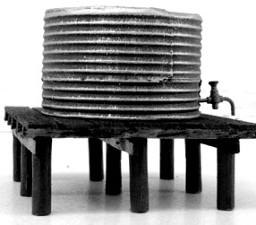

**Each important function is supported by many elements.**

**Install back-up systems for important functions wherever possible.**

**H8. Integrate rather than segregate:**

*“Many hands make light work.”*

By putting the right things in the right place, relationships develop between those things and they work together to support each other.

**FUNCTIONAL DESIGN:**

Every essential function should be supported by many components.

Important basic needs such as water, food, energy, and fire protection (*and cyclone / storm surge protection, etc.*) should be served in two or more ways. A careful farm design, for example, will include both annual and perennial pasture *and* fodder trees (poplars, willows, honey locust, and tagasaste) which are either cut and fed to domestic stock, or the stock let in for short periods of time to eat the leaves, pods, or lopped branches. In the same way, a house with a solar hot water system may also contain a back-up wood-burning stove with a water jacket to supply hot water when the sun is not shining. And for fire control, many elements (the pond, driveway, slow-burning windbreak trees, and swales) are incorporated into homestead or village design to reduce damage should wildfire occur. (Mollison and Slay, 1991, *Introduction to Permaculture*, p.8.)

**PRINCIPLES**

**Mind-map 6.**