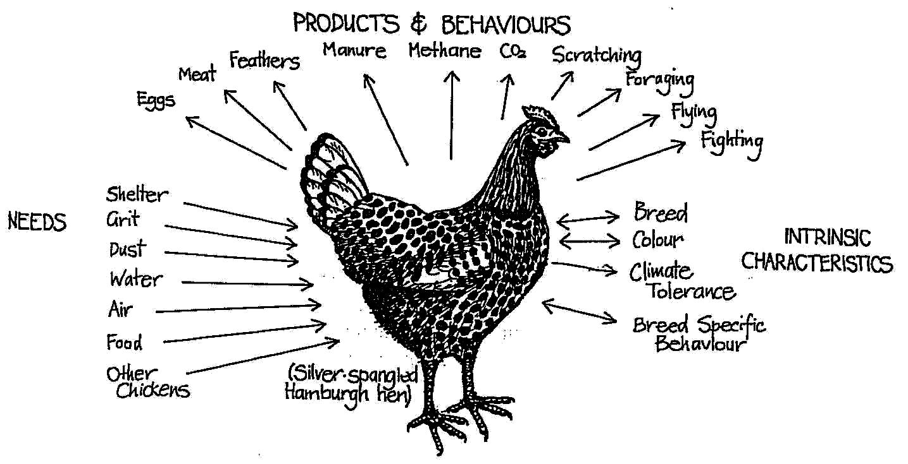

**INTRINSIC CHARACTERISTICS:**

* **Lifestyle** (annual, perennial, deciduous, evergreen, longevity);
* **Shape/height** (herb, shrub, vine, tree);
* **Canopy** (dense or light canopy cover);
* **Tolerances** - **climatic zone** (arid, temperate, sub-tropical, tropical); **sun** (full shade, part shade, full sun); **water needs** (high, medium, low); **soil** (rocky, clayey, sandy); **pH** (acid, neutral, alkaline)**; disease resistance; browsing/coppicing (**tolerances to browsing, coppicing and pruning)..
* **Rampancy** (existing or potential weed, invasive roots);

**NEEDS:**

* sunlight
* water
* nutrients
* drainage
* possibly pruning
* CO2

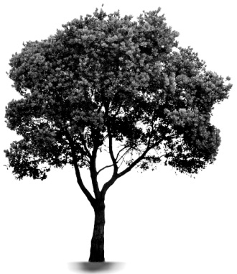

**PRODUCTS:**

* fruits
* nuts
* edible seeds
* essential oils
* fuel
* timber
* biomass / mulch
* animal forage
* medicine
* O2

**FUNCTIONAL ANALYSIS OF A TREE**

**P.I.N.**

**FUNCTIONAL ANALYSIS OF A CHICKEN**

**Set up working relationships between each element so that the *needs* of one are fulfilled by the *yields* of another.**

**7. Principle of Relative Location**

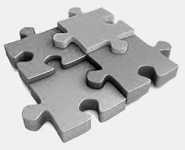

**‘Put it in**

**the right place’**

* Of what use are the products of this element to the needs of other elements?
* What needs of this element are supplied by other elements?
* Where is this element incompatible with other elements?
* Where does this element benefit other parts of the system?

**PRINCIPLE OF SELF REGULATION:**

The purpose of a functional and self-regulating design is to place elements or components in such a way that each serves the needs, and accepts the products, of other elements.

**The House** needs food, cooking fuel, heat in cold weather, hot water, lights, etc. It gives shelter and warmth for people. The chicken can supply some of these needs (food, feathers, methane). It also consumes most food waste coming from the kitchen.

**The Garden** needs fertiliser, mulch, water. It gives leaves, seeds, and vegetables. The chicken provides manures and eats surplus garden products. Chicken-pens close to the garden ensure easy collection of manures and a throw-over-the-fence feeding system. Chickens can be let into the garden, but only under controlled circumstances.

**The Greenhouse** needs carbon dioxide for plants, methane for germination, manure, heat, and water. It gives heat by day, and food for people, with some crop wastes for chickens. The chickens can obviously supply many of these needs, and utilise most of the wastes. It can also supply night heat to the greenhouse in the form of body heat if we place the chicken-house adjoining it.

**The Orchard** needs weeding, pest control, manure, and some pruning. It gives food (fruit and nuts), and provides insects for chicken forage. Thus, the orchard and the chicken can interact beneficially if the chickens are allowed in from time to time.

**The Woodlot** needs management, fire control, perhaps pest control, and some manure. It gives solid fuel, berries, seeds, insects, shelter, and some warmth. Chickens can roost in the trees, feed upon insect larvae, and assist in fire control by scratching or grazing fuels such as grasses.

**The Cropland** needs ploughing, manuring, seeding, harvesting, and storage of crops. It gives food for chickens and people. Chickens have a part to play as manure providers and cultivators (a large number of chickens on a small area will effectively clear all vegetation and turn the soil over by scratching.

**The Pasture** needs cropping, manuring, and storage of hay or silage. It gives food for animals (worms and insects included).

**The Pond** needs some manure. It yields fish, water plants as food, and can reflect light and absorb heat.

Now we have all the information needed to sketch a plan of the chicken run, to decide where fences, shelters, nests, trees, seed and green crops, ponds, greenhouses, and processing centres will go relative to the chicken.

(From Mollison, 1988, *Permaculture: A Designers’ Manual*, p.39.)

**H7. Design from patterns to details:**

*“Can’t see the forest for the trees.”*

By stepping back, we can observe patterns in nature and society. These can form the backbone of our designs, with the details filled in as we go.

**H8. Integrate rather than segregate:**

*“Many hands make light work.”*

By putting the right things in the right place, relationships develop between those things and they work together to support each other.

**STRESS AND HARMONY**

“Stress may be defined as either prevention of natural function, or of forced function; and (conversely) harmony as the permission of chosen and natural functions and the supply of essential needs”. (Mollison 1988:35)

**Incorrect location of elements leads to stress, while correct location leads to harmony.**

**PRINCIPLES**

**Mind-map 7.**