One term often used in permaculture is ‘animal tractor system’. This refers to using animals in your system, doing what they do best. Chickens are used for scratching clean an area and eating weed seeds, pigs are used for ploughing up land, goats are used to control woody weeds, cows and sheep maintain pasture areas, and worms work hard converting biological material to fertiliser. The following table details some characteristics of specific animals.

(From Mars, 2007, *The Basics of Permaculture Design*, p.124, table 11.2).

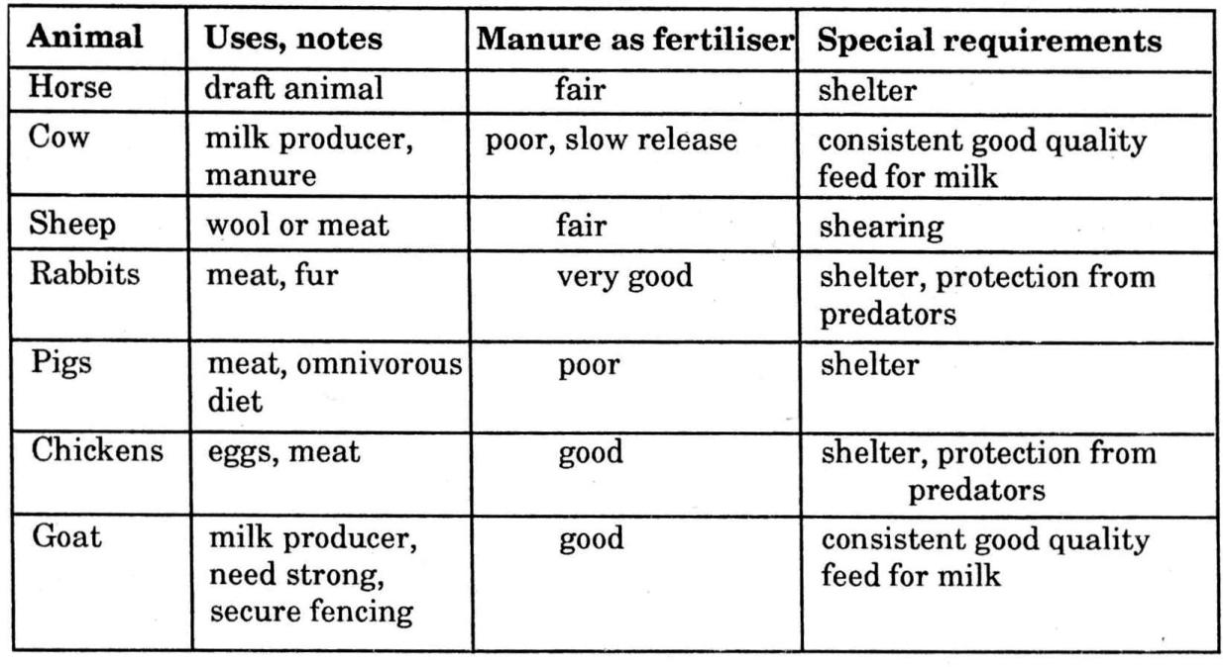

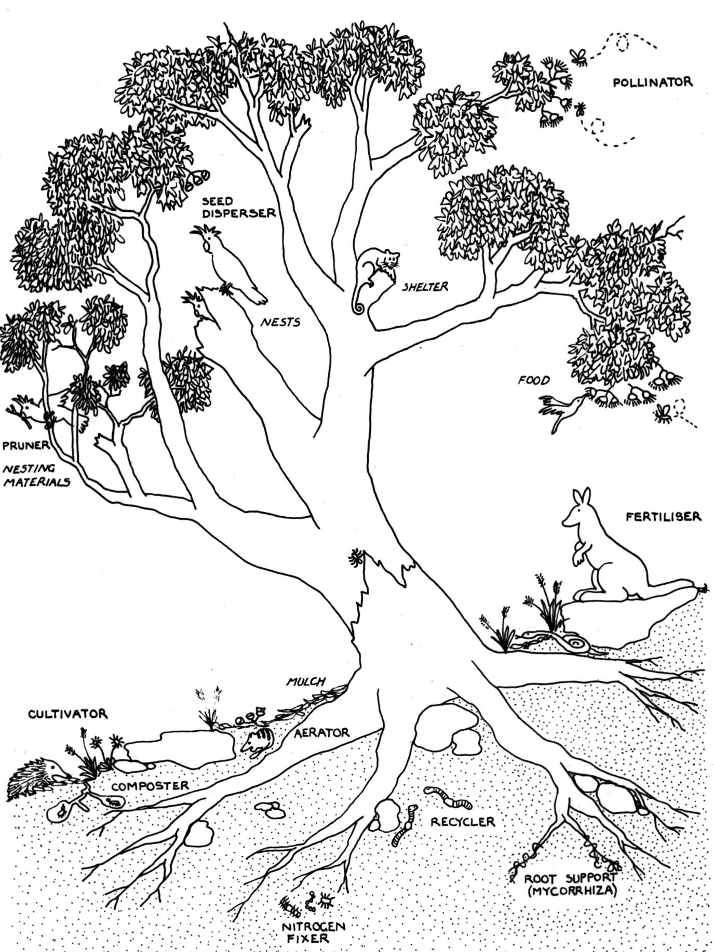

**Everything gardens, or has an effect on its environment.**

Morrow, 1993, *Earth Users Guide to Permaculture*, p.49 fig.9.1

**Use biological resources rather than mechanical or agrochemical solutions.**

A ‘**Waru’** is an Australian Aboriginal word for the complementary relationship between organisms (a ‘guild’).

**8. Principle on Biological Resource Use**

**5. Use and value renewable resources and services.**

*“Let nature take its course”.*

Make the best use of nature's abundance to reduce our consumptive behaviour and dependence on non-renewable resources.

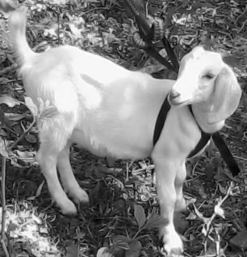

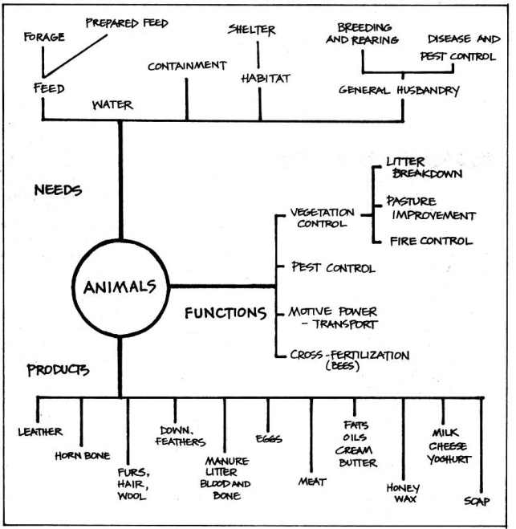

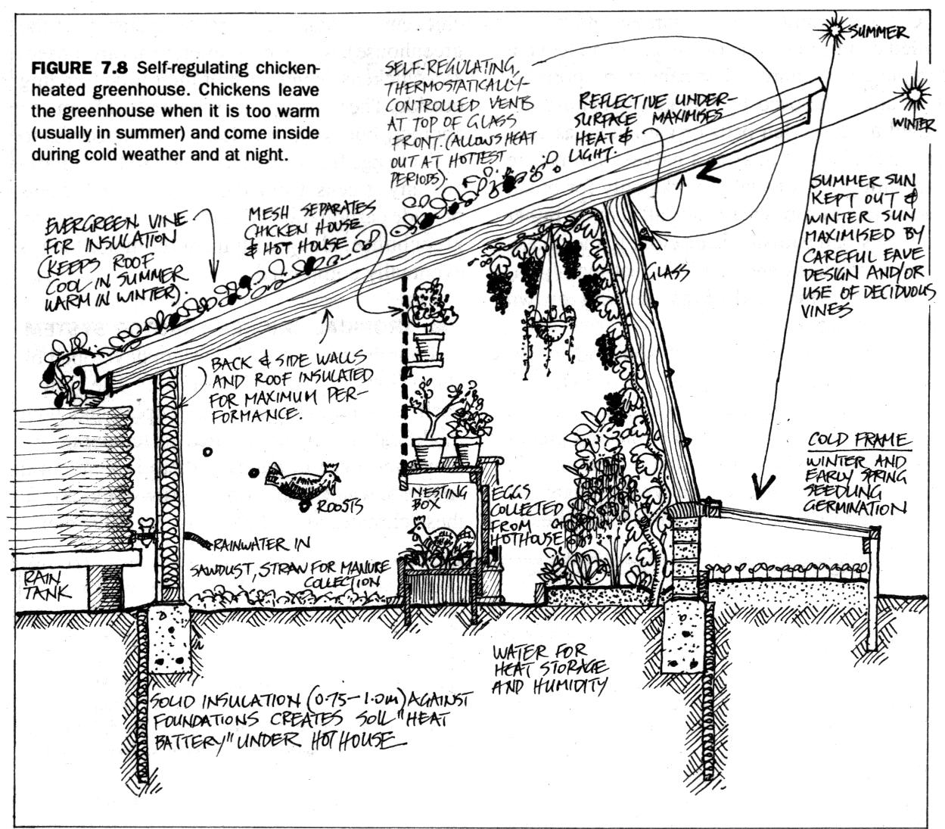

**A ‘WARU’**

*Introduction to Permaculture*, p.146, fig.7.1

Mollison & Slay, 1993, *Introduction to Permaculture*, p.154, fig.7.8

**worm castings**

**green manure**

**compost**

**PRINCIPLES**

**Mind-map 8.**

Use biological control of pests through interplanting of insect repellent and predator attracting plants, provide habitat for frogs and insectivorous birds, make insecticide spray from plants such as chilli and garlic, use derris, neem and white cedar. For herbicides, experiment with allelopathic plants and extracts.

**mushroom compost**

**animal manures**

**mulch**

**seaweed**

**legumes**