The world is fast losing its genetic diversity. While many people are aware of disappearing wild species and their habitats, not as many realise how fast we are also losing our diversity in food plants. There are perhaps as many as 300,000 edible plant species on earth, but almost 2/3 of the world’s dietary energy comes from just four species – wheat, rice, corn, and potatoes. Even within these four crops genetic diversity is decreasing rapidly. For example, it has been estimated that there were over 100,000 local strains of rice grown in Asia in 1960. Most of these varieties are now lost, replaced by a handful of hybrid varieties bred by the International Rice Research Institute (IRRI). By the mid-1990s 71% of the commercial corn crop in the U.S. came from 6 varieties, 65% of the rice from only 4 varieties, and 50% of the wheat from 9 varieties. The following table (Gleissman, 2007, *Agroecology*, p.193, table 14.2) details this trend within agrobiodiversity:

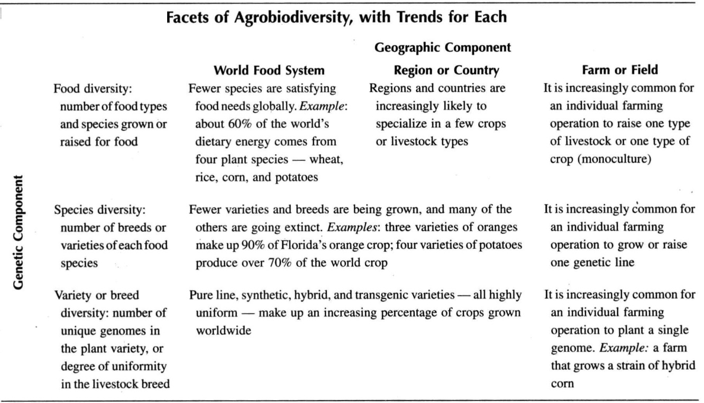

**Trend towards ‘simplification’ of world food stocks**

**Include as much diversity in a cultivated ecosystem as it can maintain itself, then let it simplify or complicate further if that is its nature.**

While diversity of itself is a potential resource, it only becomes a resource when functionally connected to other components in the system. Great diversity may create chaos or confusion, whereas a diversity of ***beneficial functional connections*** aids stability and increases yield within your system. Increasing diversity increases the ***opportunities*** for such interactions.

With higher diversity there is: greater micro-habitat differentiation; increased range of micro-climates; increased opportunities for coexistence and beneficial ‘connections’ between species; greater support for predatory insects, greater resource use, and insurance against localised crop failure.

“(D)iversity either of components or assemblies does not of itself guarantee either **Stability** or **Yield**. Where we maintain such diversity, as in our gardens, they will simplify, or simply be obliterated by non-maintained and hardy species adapted to that site (as is evident in any abandoned garden)…Great diversity may create chaos or confusion, whereas multiple function brings order and develops resources. I believe that a happy medium is to include as much diversity in a cultivated ecosystem as it can maintain itself, and to let it simplify or complicate further if that is its nature.” Mollison, 1988, *Permaculture: A Designers Manual*, p. 32

**9. Diversity Principle**

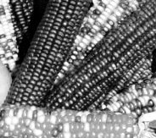

**Methods to increase diversity in an agricultural system include:**

* Heritage varieties: grow a variety of non-hybrid open pollinated vegetables
* Intercropping: growing different species together;
* Strip cropping: a row of one species grown next to another (e.g. legumes next to rice);
* Hedgerows: trees or shrubs planted around the edges of fields;
* Cover crop: planting a non-crop species for other benefits;
* Rotations: planting different crops in the one place at different times;
* Reduced or minimum tillage: increased diversity in decomposer organisms;
* High organic matter inputs: crucial for stimulating species diversity in soil;
* Fallow/weeds: areas are left ‘uncropped’ allowing weed species to grow, which are then turned in to enrich the soil;
* Cease chemical inputs: chemical fertilisers reduce diversity while organic fertilisers increase diversity:
* Integration of livestock: increases diversity through such activities as grazing, crop residue consumption, and manure deposition.

**H10. Use and value diversity.**

*“Don’t put all your eggs in one basket”.*

Diversity reduces vulnerability to a variety of threats and takes advantage of the unique nature of the environment in which it resides.

Natural ecosystems generally conform to the principle that greater diversity allows greater resistance to perturbation and disturbance. Ecosystems with high diversity tend to be able to recover from disturbance and restore balance in their processes of material cycling and energy flows; in ecosystems with low diversity, disturbance can more easily cause permanent shifts in functioning, resulting in the loss of resources from the ecosystem and changes in its species makeup. (Gliessman, 2007, *Agroecology*, p.219)

**PRINCIPLES**

**Mind-map 9.**

**GREEN HARVEST:** (great source) <www.greenharvest.com.au>

**SEED SAVERS NETWORK**

<www.seedsavers.net>

**EDEN SEEDS**

<www.edenseeds.com.au>

**DIGGERS SEEDS**

<www.diggers.com.au>

**SEED.COM.AU**

<www.seed.com.au>

**GREEN PATCH SEEDS** <www.greenpatchseeds.com.au>

**HEIRLOOM ORGANICS**

<www.non-hybrid-seeds.com>

**HEIRLOOM SEEDS**

<www.heirloomseeds.com>