Note: unwanted rampancy is a problem to be especially aware of (and control) when using hardy and self-reliant species.

Where possible use species native to the area, or those naturalised species known to be beneficial. The thoughtless introduction of potentially invasive species may upset natural balances in your home area.

**Birch’s Six Principles of Natural Systems:**

The six principles on natural systems devised by Birch are important to consider when ‘dealing with natural systems. For example, when rehabilitating a degraded area it may be necessary to introduce a very small number of selected plant species to ensure other species thrive. An example would be the planting of vines to attract butterflies or planting selected eucalyptus species to help increase the koala population in an area. "The chance that species have to survive and reproduce is dependent primarily upon one or two factors in the complex web of relations of the organism to its environment."

NOTE: For a full listing of Birch’s Six Principles on Natural Systems see *Set of Ethics on Resource Management*.

Some species noted in a number of permaculture books that are either potential or classified weed species in the Townsville region include leucaena, Indian jujube (related to Chinee Apple), tamarind and guava. Before incorporating *any* species into your system ensure it is not a locally invasive species. The *From* *Seeds to Success* book mentioned below contains an invaluable list of weeds of the Townsville/Thuringowa region.

**Species of local conservation significance in Townsville/Thuringowa region**

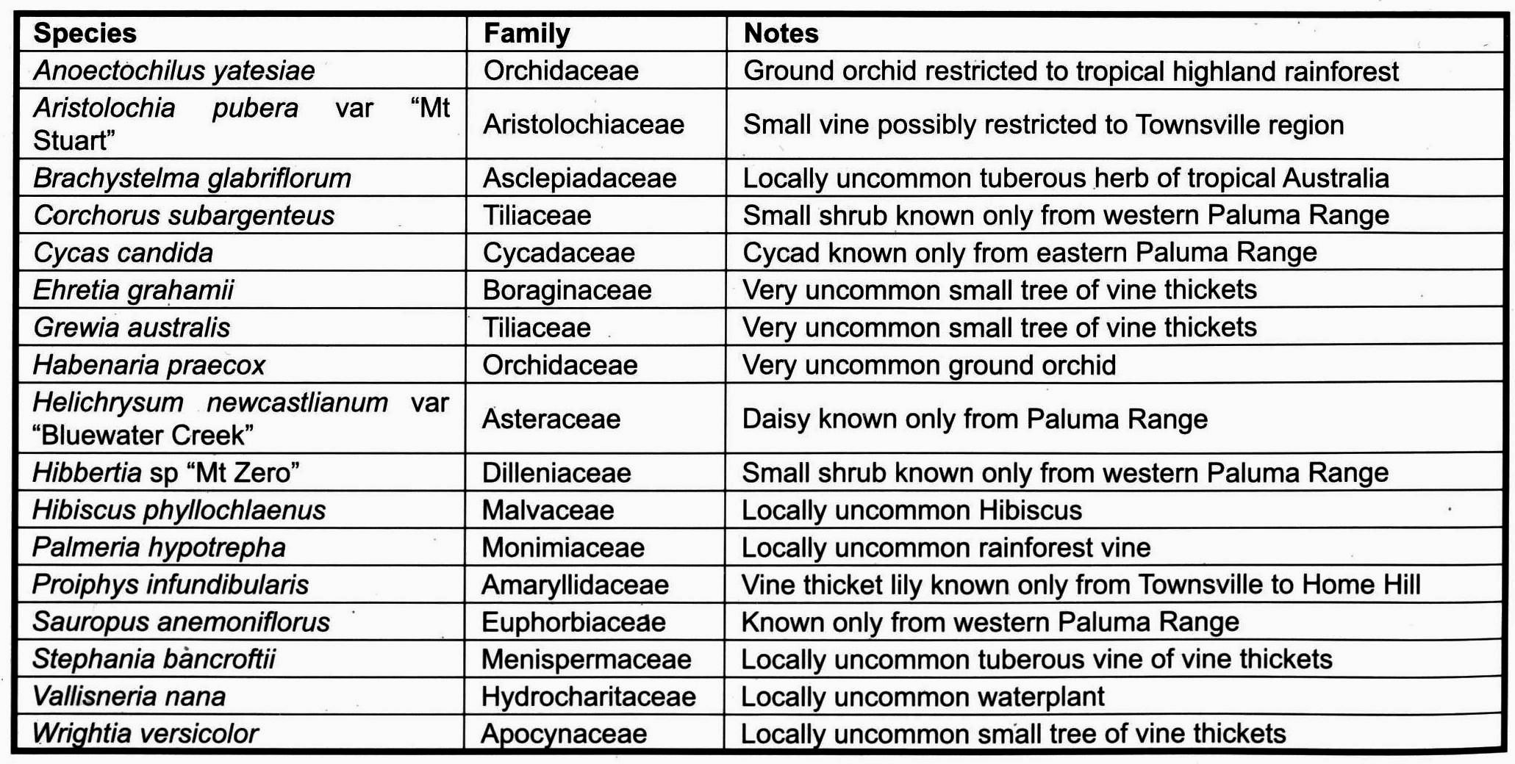

From: *Rare and threatened plants of the Townsville Thuringowa Region*. Available for $15 from Coastal Dry Tropics Landcare Inc. at Suite 1/65 Palmer Street, South Townsville or at <www.cdtli.org.au/publications>. This book is a guide to the 40 rare and threatened plants in the Townsville–Thuringowa region in north-east Queensland. Plants in the book vary from tiny rainforest filmy ferns, to orchids, shrubs and eucalypts.

Leave more space and resources for other species through the establishment of plant systems for our own use on the *least* amount of land we can use for our existence.

**Set of Ethics on Natural Systems**



Implacable and uncompromising opposition to further disturbance to any remaining natural forests and intact natural ecosystems.

In any forest we should leave a section that is not managed; it is left in its natural state for wildlife habitat and forage, and to protect fragile upper slopes against erosion. These undisturbed areas are very beautiful, peaceful places, and of intrinsic worth. We are able to contemplate nature here, and to learn about ourselves in the natural world. (Mollison 1991, p.135).

Vigorously rehabilitate degraded and damaged natural systems to a stable state.

In addition to the ethical reasons for conservation, natural systems need to be conserved for ‘practical’ reasons. We have only just begun to explore the potential medicines and products available from natural systems. They also provide us with the ultimate ‘classroom’.

*From Seeds to Success—a bush regeneration manual for Townsville, Thuringowa and the Burdekin* (2003). Available for $15 from Coastal Dry Tropics Landcare Inc. at Suite 1/65 Palmer Street, South Townsville or at <www.cdtli.org.au/publications>. They also provide a free booklet titled *Plant Species for Revegetation in the Townsville Thuringowa Region*.

Establish plant and animal refuges for rare or threatened species.

NOTE: Rather than a separate area for rare or threatened species, individual species can be incorporated into your permaculture system.

**NATURAL SYSTEMS ETHICS**

**Mind-map E2.**